# CRM Application for Jewel

**Management (Developer)**

# 

**COLLEGE NAME - DR. R.V. ARTS AND SCIENCE COLLEGE**

**COLLEGE CODE -** **bru5b**

**TEAM MEMBERS**

**TEAM ID:**  **NM2025TMID27596**

**Team Leader: FYROZE B**

**Email: fyrozeucas@gmail.com**

**Team Member 1: MONIKA SHREE T J**

**Email: monikashree729@gmail.com**

**Team Member 2: SUNSHINE ALLINE J**

**Email: allinesunshine@gmail.com**

**Team Member 3: NIVETHA B**

**Email: nivethanivinivi402@gmail.com**

**Team Member 4: SARANYA C**

**Email:** **saranlatha383@gmail.com**

**INTRODUCTION**

## Project Overview

The Jewel Inventory System is a comprehensive software Solution designed to streamline and manage the inventory and sales processes of a jewellery store or a jewellery manufacturer. The system aims to provide an efficient and user-friendly solution to track and control the inventory of various jewellery items, maintain accurate records, and facilitate seamless sales transactions.

**Purpose**

The purpose of this project is to develop a CRM-based Jewel Inventory System that helps jewellery businesses efficiently manage their inventory and sales processes. By providing a user-friendly and automated platform, the system aims to improve accuracy in record-keeping, streamline sales transactions, and enhance overall operational efficiency. Additionally, it offers customization and automation features through Salesforce to support better decision-making and customer relationship management.

**DEVELOPMENT PHASE**

**Creating Developer Account:**

By using this URL[**-**](https://www.salesforce.com/form/developer-signup/?d=pb) <https://developer.salesforce.com/signup>

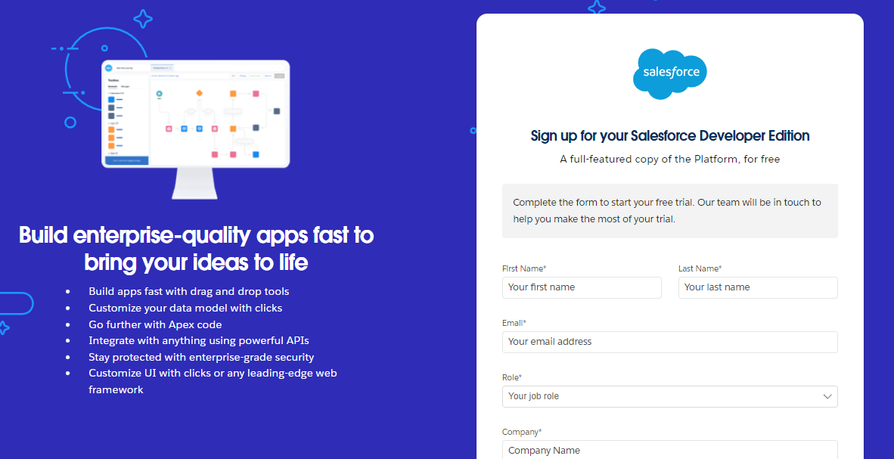

* Activate your account: Click on the “Reset Password” in the email to activate your Salesforce account.

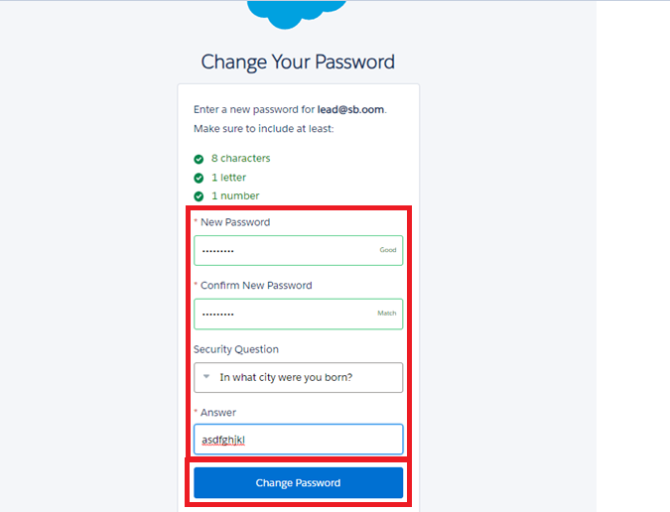

* Then you will redirect to your salesforce setup page.

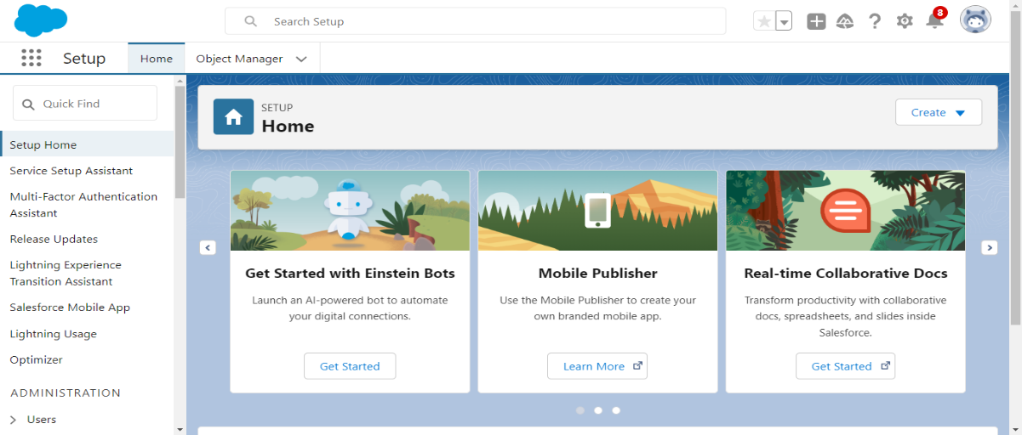

### **What is Object in Salesforce?**

Salesforce objects are database tables that permit you to store data that is specific to an organization. What are the types of Salesforce objects

Salesforce objects are of two types:

1. **Standard Objects**: Standard objects are the kind of objects that are provided by salesforce.com such as users, contracts, reports, dashboards, etc.
2. **Custom Objects:** Custom objects are those objects that are created by users. They supply information that is unique and essential to their organization. They are the heart of any application and provide a structure for sharing data.

### **Create Jewel Customer Object**

The purpose of creating a Jewel Customer custom object is to store and manage information about Customer.

To create an object:

1. From the setup page >> Click on Object Manager >> Click on Create >> Click on Custom Object
2. Enter the label name: Jewel Customer
3. Plural label name: Jewel Customer
4. Enter Record Name Label and Format
   * + Record Name >> Customer name
     + Data Type >> Text
5. Click on Allow reports, Allow search and click on Save.

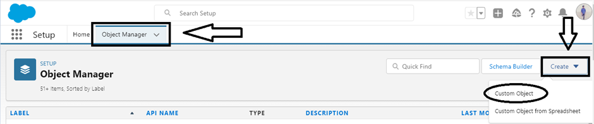

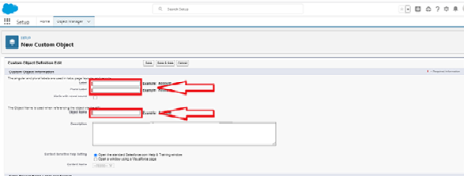

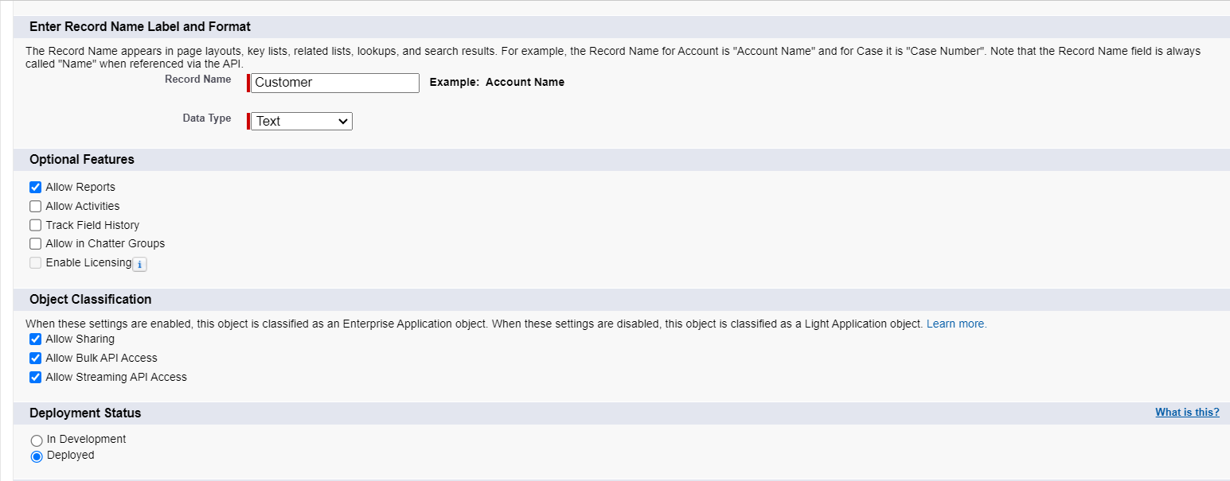

### **Create Item Object**

From the setup page >> Click on Object Manager >> Click on Create >> Click on Custom Object.

1. Enter the label name >> Item
2. Plural label name >> Items
3. Enter Record Name Label and Format

* Record Name >> Item Id
* Data Type >> Auto Number
* Display Format >> Item-{00}
* Starting Number >> 1

1. Click on Allow reports.
2. 5Allow search >> Save.

## Note: Create 3 more objects with label names as Customer Order, Price and Billing

**(Use “Auto Number” as a data type for Customer Order, Price and Billing).**

# ****Tabs in Salesforce****

A **Tab** is a user interface element used to create, view, and manage records in Salesforce objects. Tabs allow easy access to data and functionality within the Salesforce application.

# ****Types of Tabs****

1. **Custom Tabs**  
   Used for custom objects created in Salesforce. These tabs behave like standard tabs (e.g., Accounts, Contacts).
2. **Web Tabs**  
   Display external web content or applications inside the Salesforce interface. Useful for quick access without leaving Salesforce.
3. **Visualforce Tabs**  
   Display Visualforce pages within a tab. These tabs function similarly to standard tabs and are used for custom UI built using Visualforce.
4. **Lightning Component Tabs**  
   Allow Lightning components to be added to the navigation menu in Lightning Experience and the Salesforce mobile app.
5. **Lightning Page Tabs**  
   Used to add Lightning Pages to the mobile app navigation menu. Unlike other tabs, they don’t appear on the **All Tabs** page or in the **Available Tabs** list during app customization.

### **Now Creating a Custom Tab**

To create a Tab:(Customer)

1. Go to setup page >> type Tabs in Quick Find bar >> click on tabs >> New (under custom object tab)
2. Select Object (Jewel Customer) >> Select any tab style >> Next (Add to profiles page) keep it as default >> Next (Add to Custom App) keep it as default >> Save.

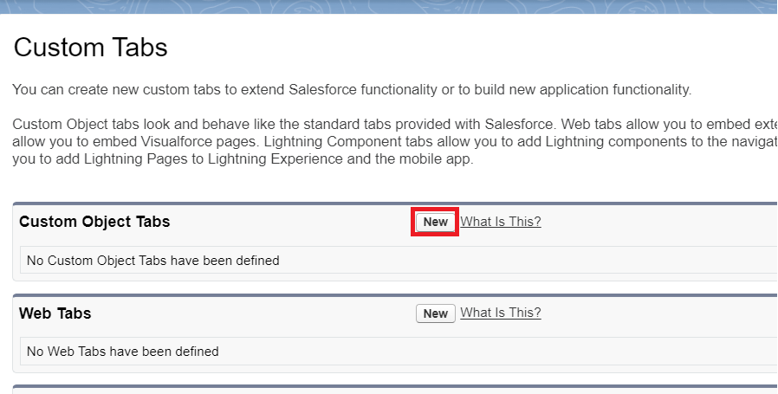

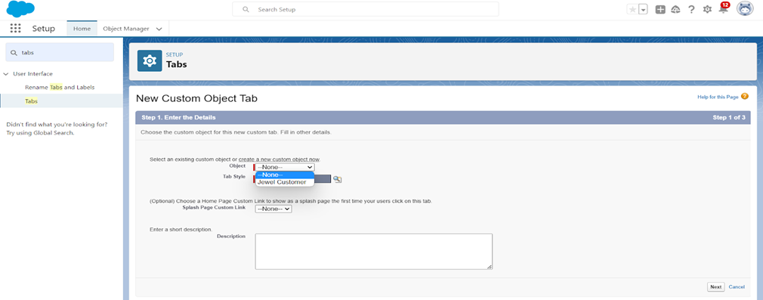

### **To create a Tab:(Item)**

1. Go to setup page >> type Tabs in Quick Find bar >> click on tabs >> New (under custom object tab)
2. Select Object (Item) >> Select the tab style >> Next (Add to profiles page) keep it as default >> Next (Add to Custom App) keep it as default >> Save.

Note: Now create tabs for Customer Order, Price, Billing objects.

### **The Lightning App**

An app is a collection of items that work together to serve a particular function. In Lightning Experience, Lightning apps gives users access to sets of objects, tabs, and other items all in one convenient bundle in the navigation bar.

Lightning apps let you brand your apps with a custom color and logo. You can even include a utility bar and Lightning page tabs in your Lightning app. Members of your org can work more efficiently by easily switching between apps.

### **Create a Lightning App**

1. Go to setup page >> search “app manager” in quick find >> select “app manager” >>
2. click on New lightning App.
3. Fill the app name in app details and branding as follow  
   App Name: Jewellery Inventory System.  
   Developer Name: This will auto populated  
   Description: Elevate your look with elegance  
   Image: optional (if you want to give any image you can otherwise not mandatory)  
   Primary colour hex value: keep this default.
4. Then click Next >> (App option page) Set Navigation Style as Console Navigation >> Next.
5. Utility Items) keep it as default >> Next.
6. **To Add Navigation Items:** Search for the item in the (JewelCustomer, Item, CustomerOrder, Price, Billing, Reports, Dashboard) from the search bar and move it using the arrow button? Next? Next.

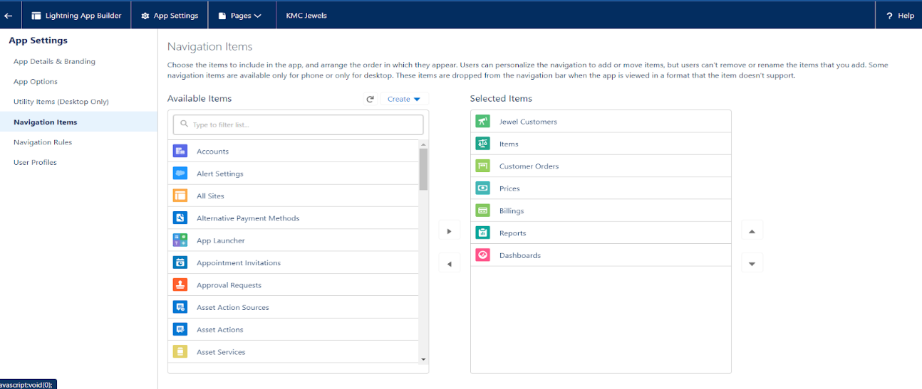

**7. To Add User Profiles:** Search profiles (System administrator)

in the search bar >> click on the arrow button >> save & finish.

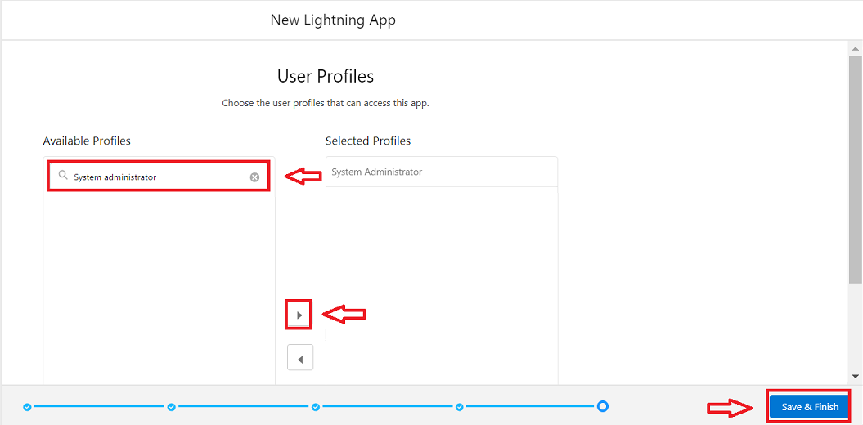

# ****Fields in Salesforce****

In Salesforce, **Fields** represent the individual pieces of data stored in the columns of a relational database. They are used to store specific information within an object, making the process of searching, editing, and deleting records faster and more efficient.

# ****Types of Fields****

1. **Standard Fields**
   * Predefined by Salesforce and perform standard tasks.
   * Some standard fields cannot be deleted, especially if they are required.
   * Common standard fields include:
     + **Created By**
     + **Owner**
     + **Last Modified**
     + **Field created during object creation**
2. **Custom Fields**
   * Created by users based on specific business needs.
   * Highly flexible and customizable.
   * Can be added or removed as needed, unlike standard fields.
   * Useful for storing unique information specific to an organization.

### **Creating Lookup Relationship**

A Lookup relationship is a type of relationship in Salesforce that connects two objects together based on a field known as the Lookup field. It establishes a relationship between a child object and a parent object, allowing the child object to reference the parent object.

## To Create a relationship between Jewel Customer & Customer Order Objects.

1. Go to the setup page >> click on object manager >> type object name (Customer Order) in the quick find bar >> click on the object.
2. Click on fields & relationship >> click on New.
3. Select “Lookup relationship” as data type and click Next.
4. Select the related object “ JewelCustomer ”.
5. Give Field Label as “Customer” and click Next.
6. Next >> Next >> Save.

### **Creating a Master-Detail Relationship**

Master-detail relationship is a type of relationship between two objects where the master object controls certain behaviours and settings of the detail object. Here are a few use cases that demonstrate the use of master-detail relationships

**Creating Master-Detail Relationship between Item & Customer Order Object.**

1. Go to the setup page >> click on object manager >>type object name (Customer Order) in the quick find bar >> click on the object.

2. Click on fields & relationships >> click on New.

3. Select “Master-Detail relationship” as data type and click Next.

4. Select the related object “Item”.

5. Give Field Label as “Item” and click Next.

6. Next >> Next >> Save.

**Creating Text Field in Jewel Customer Object**

Go to setup >> click on Object Manager >> type object name (Jewel Customer) in quick find bar >> click on the object.

* Now click on “Fields & Relationships” >> New
* Select Data type as “Text”.
* Click on Next

**Fill the above as following:**

* + Field Label: City
  + Length: 20
  + Field Name: gets auto generated And Click on Next >> Next >> Save and new.

### **Creating the Phone field in object Jewel Customer**

To create fields in an object:

1. Go to setup >> click on Object Manager >> type object name (Jewel Customer) in quick find bar >> click on the object.
2. Now click on “Fields & Relationships” >> New
3. Select Data type as “Phone” and click Next.
4. Given the Field Label as “Phone”.
5. Field Name will be auto populated, and click on Next >> Next >> Save & new.

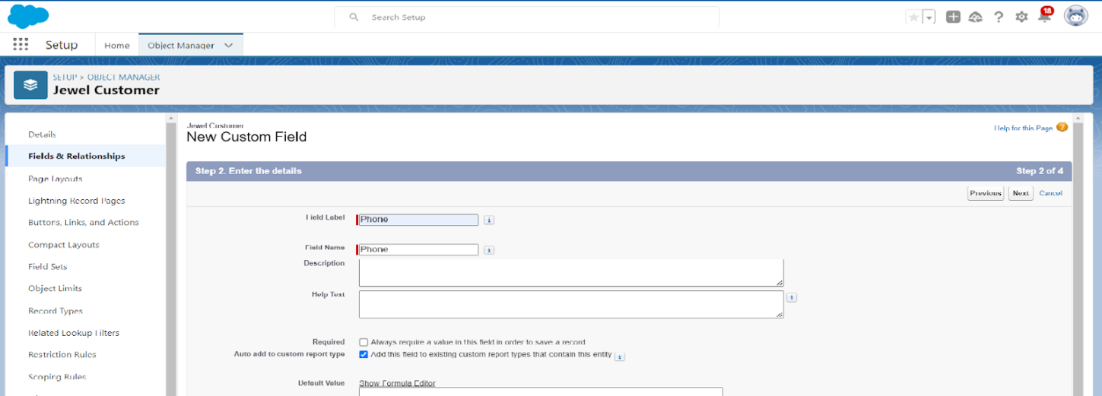

**Creating the Email field in object Jewel Customer**

1. Go to setup >> click on Object Manager >> type object name (Jewel Customer) in quick find bar >> click on the object.
2. Now click on “Fields & Relationships” >> New
3. Select Data type as “Email” and click Next.
4. Given the Field Label as “Email”.
5. Field Name will be auto populated, and click on Next >> Next >> Save.

### **Creating the number field in Item object**

1. Go to setup >> click on Object Manager >> type object name (Item) in quick find bar? click on the object.
2. Now click on “Fields & Relationships” >> New
3. Select Data type as “Number” and click Next.
4. Given the Field Label as “Purity” and length as “2”.
5. Field Name will be auto populated, and click on Next >> Next >> Save.

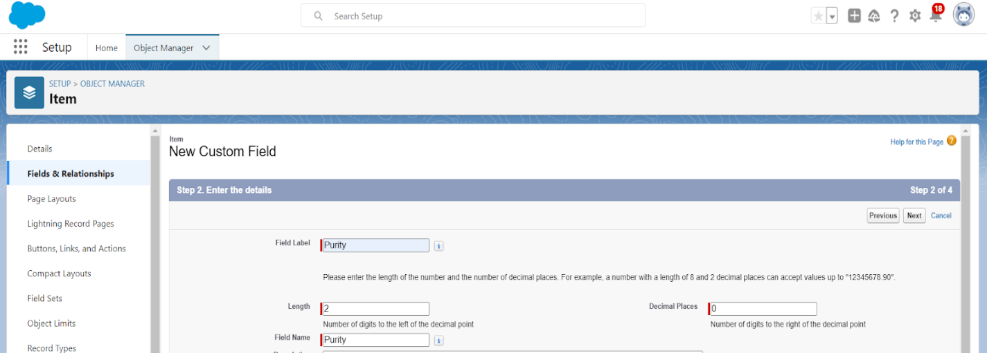

### **Creating Picklist Field in Item Object**

1. Go to setup >> click on Object Manager >> type object name (Item) in quick find bar>> click on the object.
2. Now click on “Fields & Relationships” >> New.
3. Select Data type as “Picklist” and click Next.
4. Enter Field Label as “Item Type”.
5. In values select “Enter values (Gold, Silver), with each value separated by a new line" and enter values as shown below.
6. Click Next? Next? Next? Save

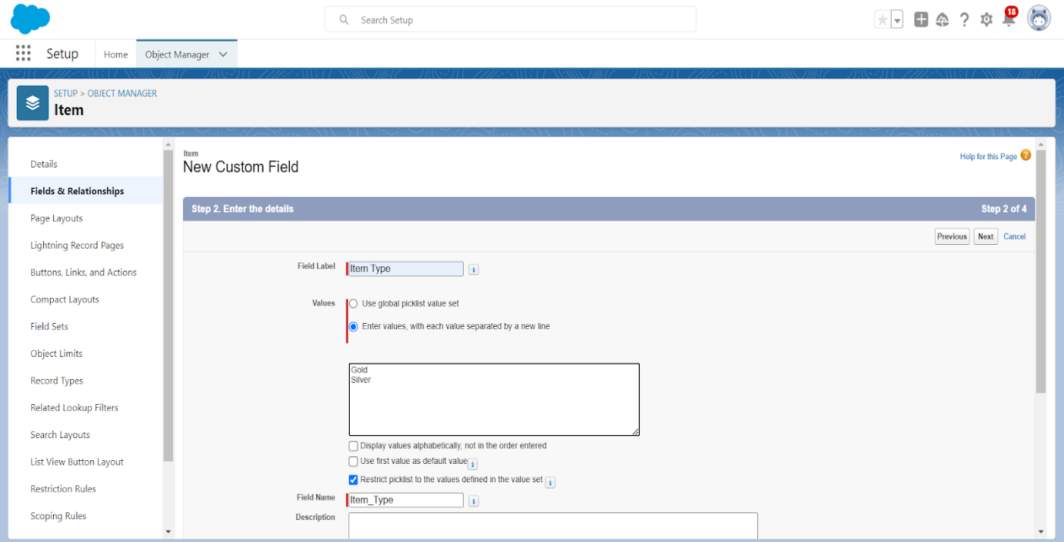

### **Creating Currency Field in Price Object**

1. Go to setup >> click on Object Manager >> type object name (Price) in quick find bar >> click on the object.
2. Now click on “Fields & Relationships” >> New.
3. Select Data type as “Currency” and click Next.
4. Enter Field Label as “Gold Price” and length as “8”and decimal 0.
5. Click Next >> Next >> Next >> Save.

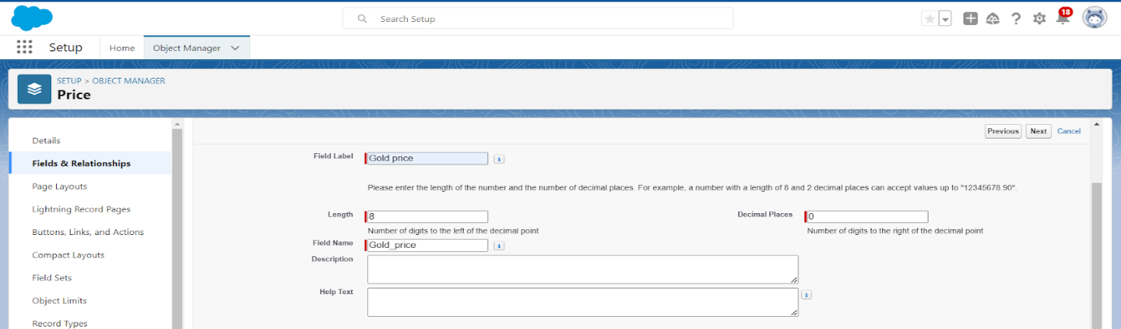

### **Creating Formula Field (Cross Object) in Item Object**

(Note: Create a Lookup Relationship in Item Object to Price Object with Field Name: Prices)

1. Go to setup >> click on Object Manager >> type object name (Item) in quick find bar? click on the object.
2. Now click on “Fields & Relationships” >> New.
3. Select Data type as “Formula” and click Next.
4. Give Field Label and Field Name as “Gold Price” and select formula return type as “Currency” and click next.
5. Under Advanced Formula write down the formula: Prices__r.Gold_price__c  / 10.
6. click “Check Syntax” and Next >> Next >> Save & New.

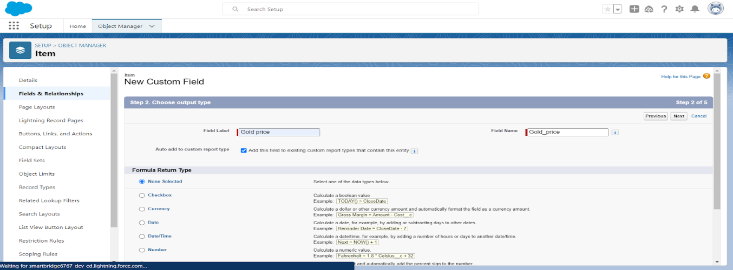

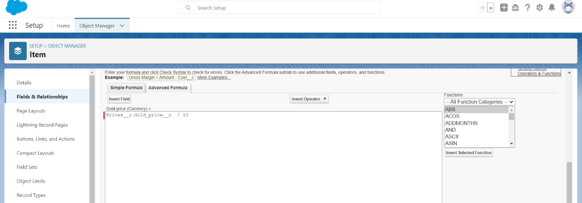

**Schema Builder**

Schema Builder is a powerful tool within Salesforce that allows you to visualise, explore, and design the relationships between objects in your Salesforce organisation. It provides a graphical representation of the data model, making it easier to understand the structure and connections between different objects.

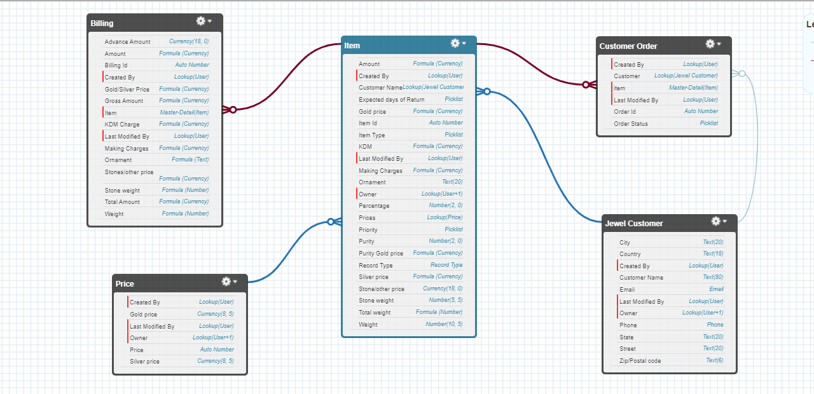

### **Creating the Field Dependencies**

Field Dependencies are used to create relationships between fields within an object. They allow you to control the visibility and availability of fields based on the values selected in other fields.

1. Go to setup >> click on Object Manager >> type object name (Item) in quick find bar >> click on the object.
2. Click on Fields & Relationships and click on the Priority field.
3. Search for Field Dependencies and click on New.
4. Select Controlling Field as “Priority” and Depending field as “Expected Days of Return” >> Continue.
5. Select the “Expected Days of Return” values of related Priority values and Click on Include Values >> Save.

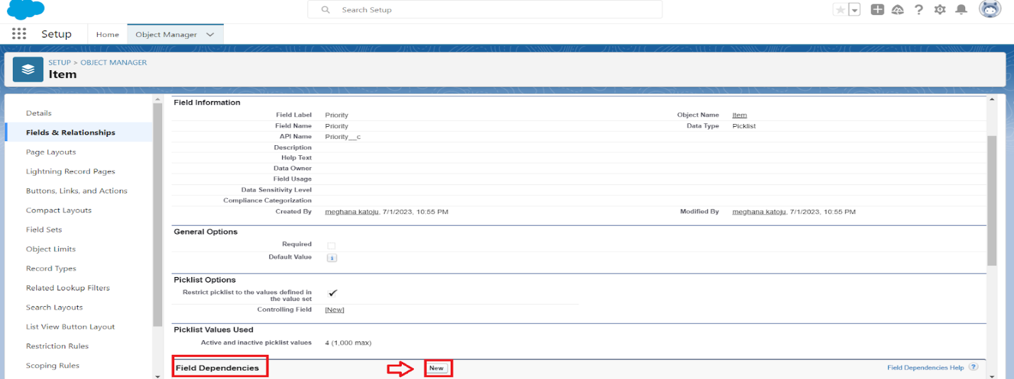

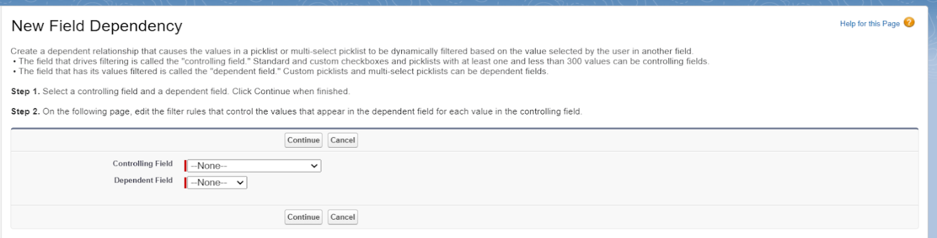

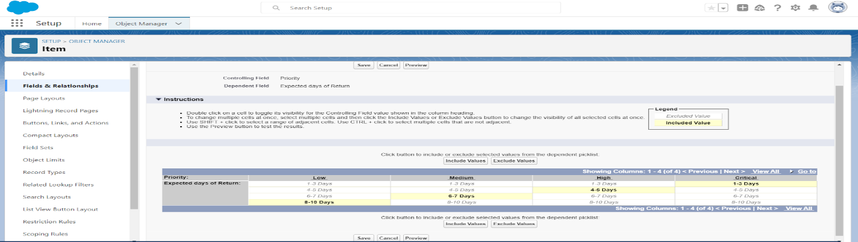

### **Creating the validation rule**

Creating the validation rule for Postal Code field in Jewel Customer object

Note: check whether the fields mentioned in the formula field are created or not, if not go to activity 10 and create those fields mentioned in Jewel Customer object.

1. Go to setup >> click on Object Manager >> type object name (Jewel Customer) in quick find bar>> click on the object.
2. Click on the validation rule >> click New.
3. Enter the Rule name as “Postal Code “.
4. Insert the Error Condition Formula as: -  
   AND(  
       OR(  
           LEN( Zip_Postal_code__c ) <> 6, NOT(REGEX(Zip_Postal_code__c, "^[0-9]{6}$"))),  
           NOT(ISBLANK(Zip_Postal_code__c))  
       )  
   )
5. Enter the Error Message as “Must contain 6 digits”, select the Error location as Field and select the field as “Zip/Postal code”, and click Save.

**NOTE: Create One more Validation rule for Jewel Customer object.**

1. Enter Rule name as “ValidationRule For JewelCustomerObject “.
2. Insert the Error Condition Formula as: -  
   OR( ISBLANK( City__c ) , ISBLANK( Country__c ),ISBLANK( Phone__c ),ISBLANK( State__c ),ISBLANK(     Street__c ) )
3. Enter the Error Message as “Please fill Required fields”, select the Error location as Top of Page and click Save.

**Create Validation rule for Item object.**

1. Enter Rule name as “ValidationRule For Item“.
2. Insert the Error Condition Formula as : -  
   OR( ISBLANK(  Amount__c  ) , ISBLANK(  Customer_Name__c  ) ,ISBLANK( Gold_price__c ),ISBLANK( KDM__c ),ISBLANK( Ornament__c ),ISBLANK( Percentage__c ),ISBLANK( Making_Charges__c ),ISBLANK( Prices__c ),ISBLANK( Stone_weight__c ),ISBLANK( Silver_price__c ),ISBLANK( Stone_other_price__c ),ISBLANK( Stone_weight__c ),ISBLANK( Weight__c ))
3. Enter the Error Message as “Please fill Required fields”, select the Error location as Top of Page and click Save.

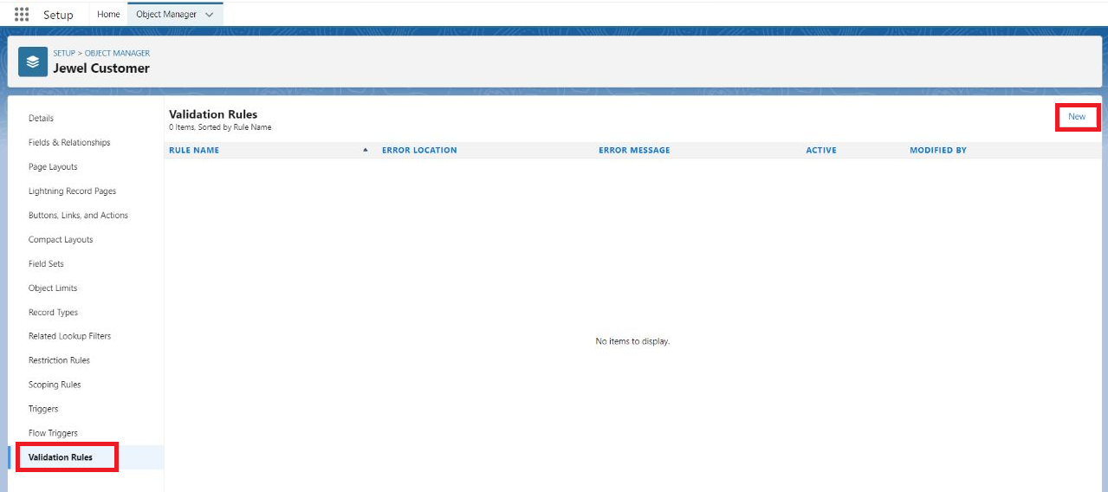

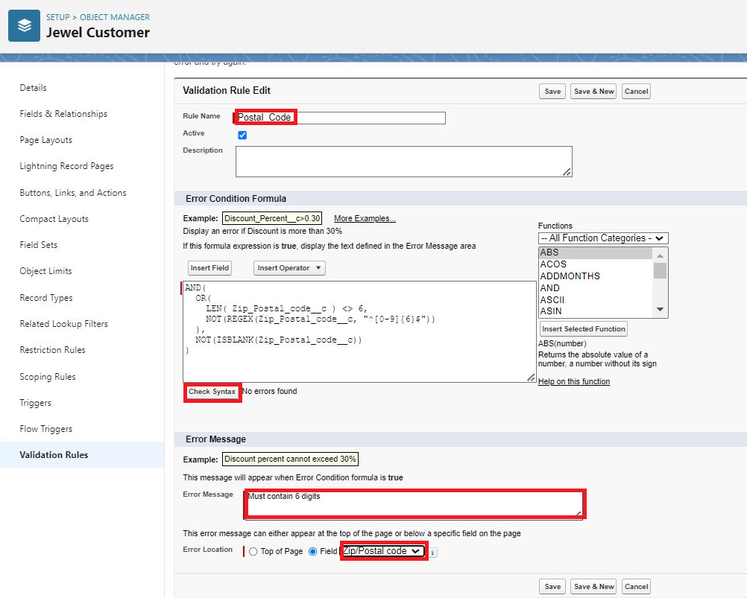

### **Profiles**

A profile is a group/collection of settings and permissions that define what a user can do in salesforce. Profile controls “Object permissions, Field permissions, User permissions, Tab settings, App settings, Apex class access, Visualforce page access, Page layouts, Record Types, Login hours & Login IP ranges. You can define profiles by the user's job function. For example System Administrator, Developer, Sales Representative.

**Types of profiles in salesforce**

1. **Standard profiles:**

By default Salesforce provides below standard profiles.

* Contract Manager
* Read Only
* Marketing User
* Solutions Manager
* Standard User
* System Administrator.

We cannot deleted standard ones

Each of these standard ones includes a default set of permissions for all of the standard objects available on the platform.

1. **Custom Profiles:**

Custom ones defined by us.

They can be deleted if there are no users assigned with that particular one.

### **Gold Smith Profile**

1. Go to setup >> type profiles in quick find box >>click on profiles? clone the desired profile (System Administrator) >> enter profile name (Gold Smith) >> Save.
2. While still on the profile page, then click Edit.
3. Scroll down to Custom Object Permissions and Give access permissions for Jewel Customer, Item, Customer Order, Prices, Billings.
4. Scroll down and Click on Save.

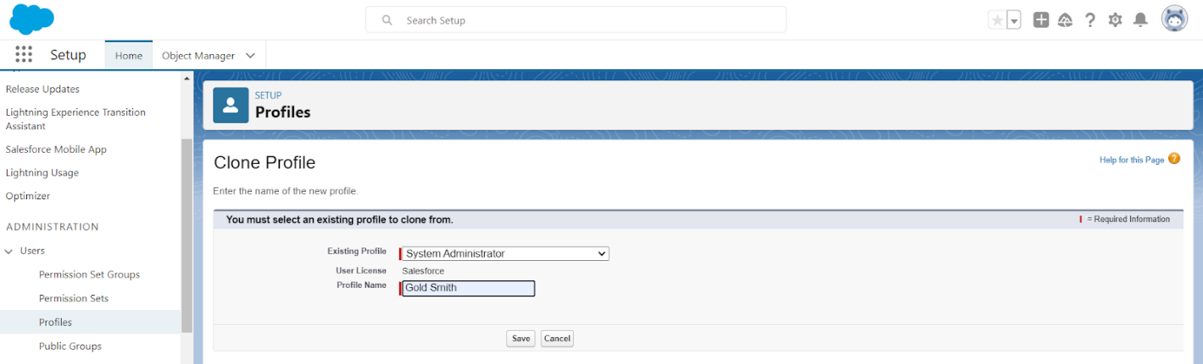

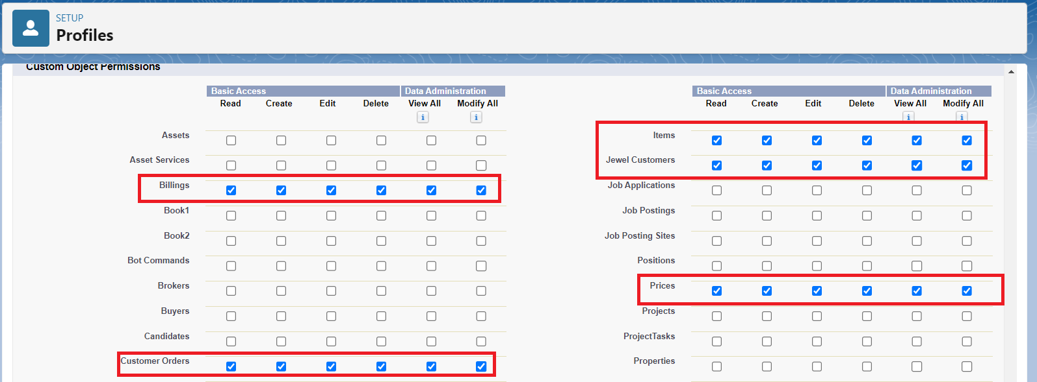

### **Worker Profile**

1. Go to setup >> type profiles in quick find box >> click on profiles >> clone the desired profile (Salesforce Platform User) >> enter profile name () >> Save.
2. While still on the profile page, then click Edit.
3. Scroll down to Custom Object Permissions and Give access permissions for Items,Price and Customer Order objects.
4. Scroll down and Click on Save.

### **Roles**

A role in Salesforce defines a user's visibility access at the record level. Roles may be used to specify the types of access that people in your Salesforce organisation can have to data. Simply put, it describes what a user could see within the Salesforce organisation.

### **Creating Gold Smith Role**

1. From setup, Go to quick find >> Search for Roles >> click on set up roles.
2. Click on Expand All and click on add role under whom this role works.
3. Give Label as “Gold Smith” and Role name gets auto populated. Check to whom this role (Gold Smith) reports. Then click on Save.

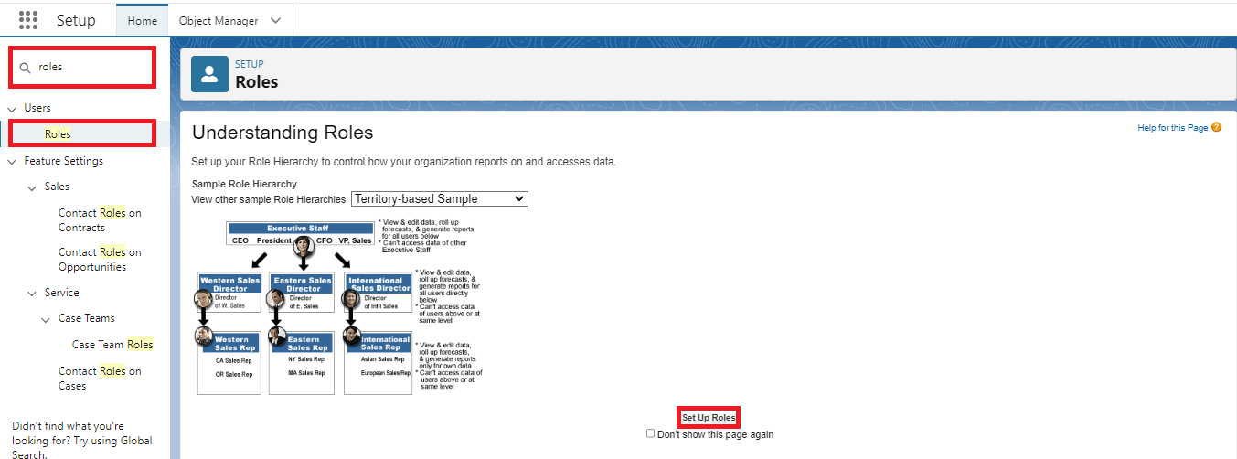

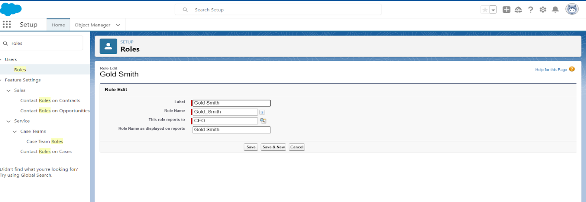 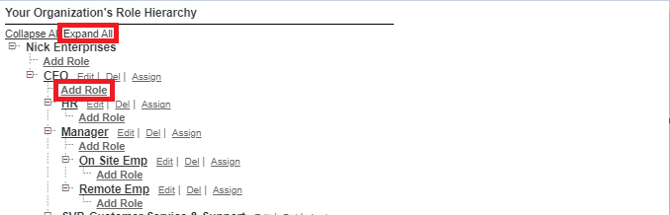

Create one more role as Worker which reports to Gold Smith

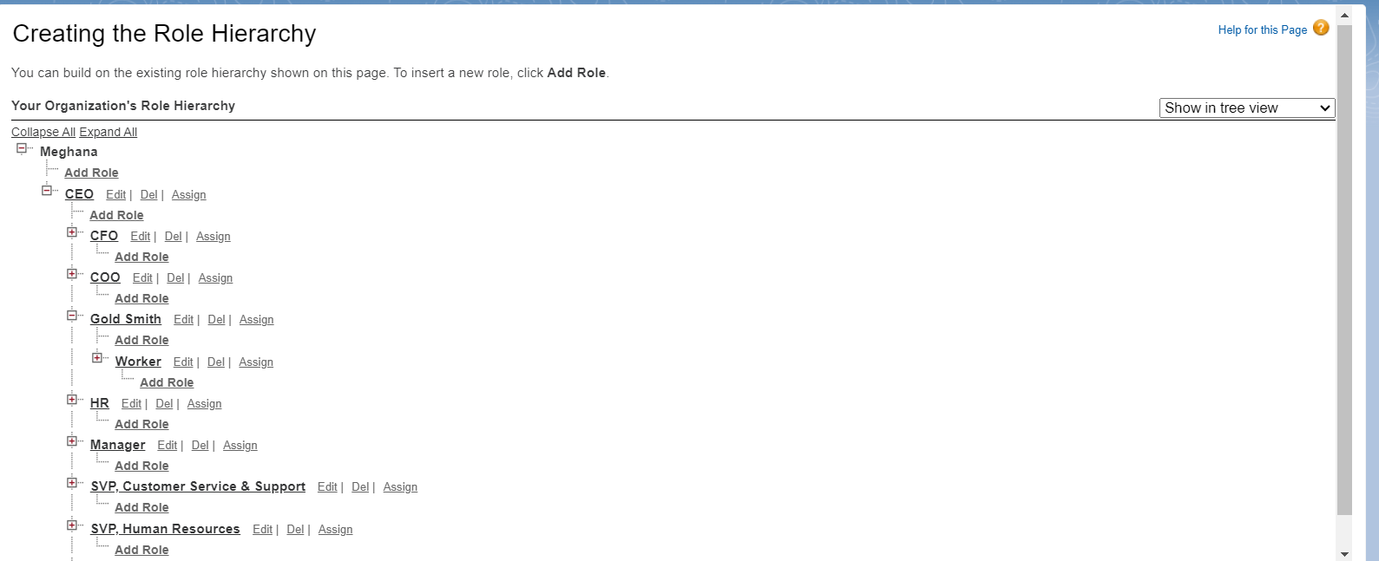

### **Users**

A user is anyone who logs in to Salesforce. Users are employees at your company, such as sales reps, managers, and IT specialists, who need access to the company's records. Every user in Salesforce has a user account. The user account identifies the user, and the user account settings determine what features and records the user can access.  
  
Every user in Salesforce has a user account. The user account identifies the user, and the user account settings determine what features and records the user can access. Each user account contains at least the following:

* Username
* Email Address
* User's First Name (optional)
* User's Last Name
* Alias
* Nickname
* Licence
* Profile
* Role (optional)

### **Create User**

Go to setup >> type users in quick find box >> select users >> click New user.

Fill in the fields

1. First Name : Niklaus
2. Last Name : Mikaelson
3. Alias : Give a Alias Name
4. Email id : Give your Personal Email id
5. Username : Username should be in this form: text@text.text
6. Nick Name : Give a Nickname
7. Role : Gold Smith
8. User licence : Salesforce
9. Profiles : Gold Smith

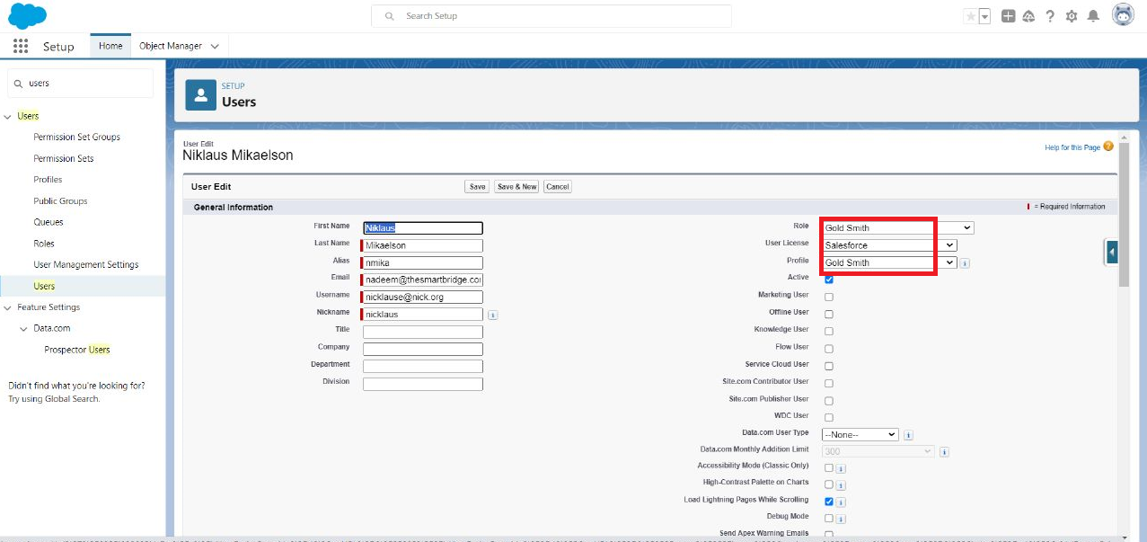

### **Create User**

Go to setup >> type users in quick find box >> select users >> click New user.

Fill in the fields

* First Name: Kol
* Last Name: Mikaelson
* Alias: Give a Alias Name
* Email id : Give your Personal Email id
* User name: Username should be in this form: text@text.text
* Nick Name: Give a Nickname
* Role: Worker
* Userlicence: Salesforce Platform
* Profiles: Worker
* Save.

## Note: Create two more users as mentioned in activity 2 using the same profile.

### **Page layouts**

Page Layout in Salesforce allows us to customise the design and organise detail and edit pages of records in Salesforce. Page layouts can be used to control the appearance of fields, related lists, and custom links on standard and custom objects' detail and edit pages.

### **To Create a Gold Page layout**

1. Go to Setup >> Click on Object Manager >> Search for the object (Item) >> From drop down click on Edit.
2. Click on Page layout >> Click on New.
3. Give Page layout Name as “Page Layout for Gold” and click on Save and New.
4. Arrange the field as shown in the Information Section, remove fields which are related to Silver and click Ok.
5. Click Save.
6. Make sure your page layout looks like the picture above.

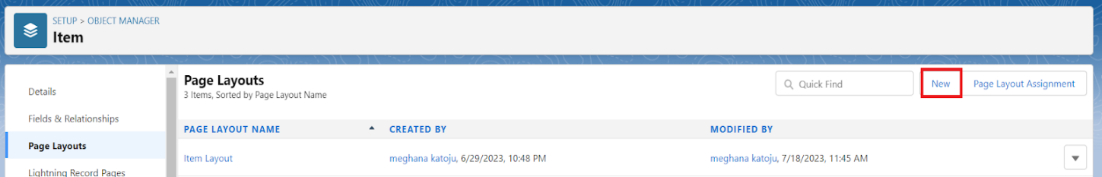

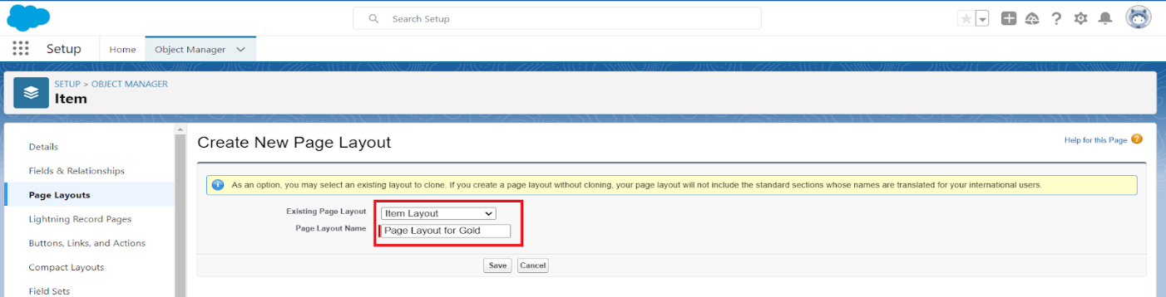

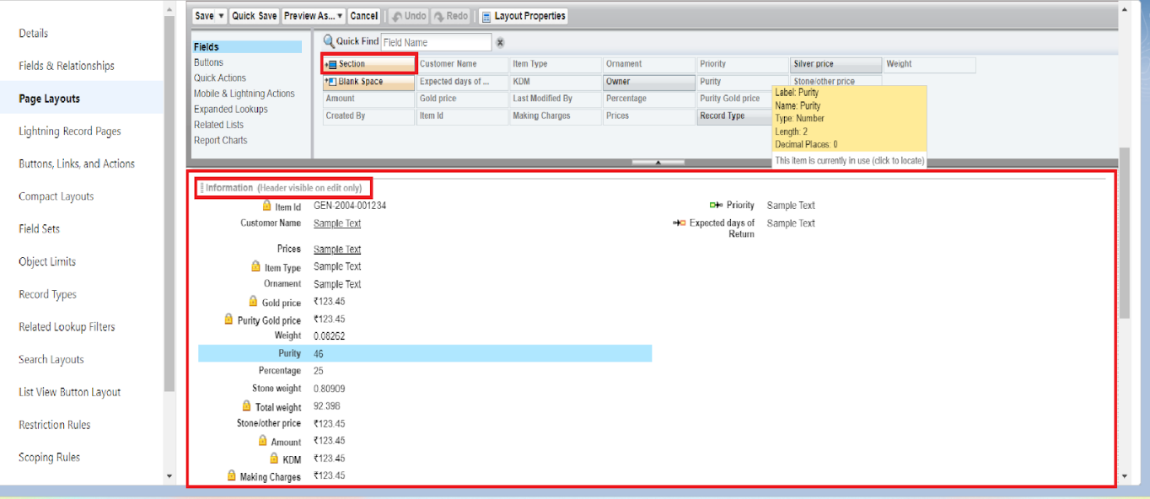

**To Create a Silver Page layout**

1. Go to Setup >> Click on Object Manager >> Search for the object (Item) >> From drop down click on Edit.
2. Click on Page layout >> Click on New.
3. Give Page layout Name as “Page Layout for Silver” and click on Save.
4. Arrange the field as shown in the Information Section, remove fields which are related to Gold  and Click on Ok.

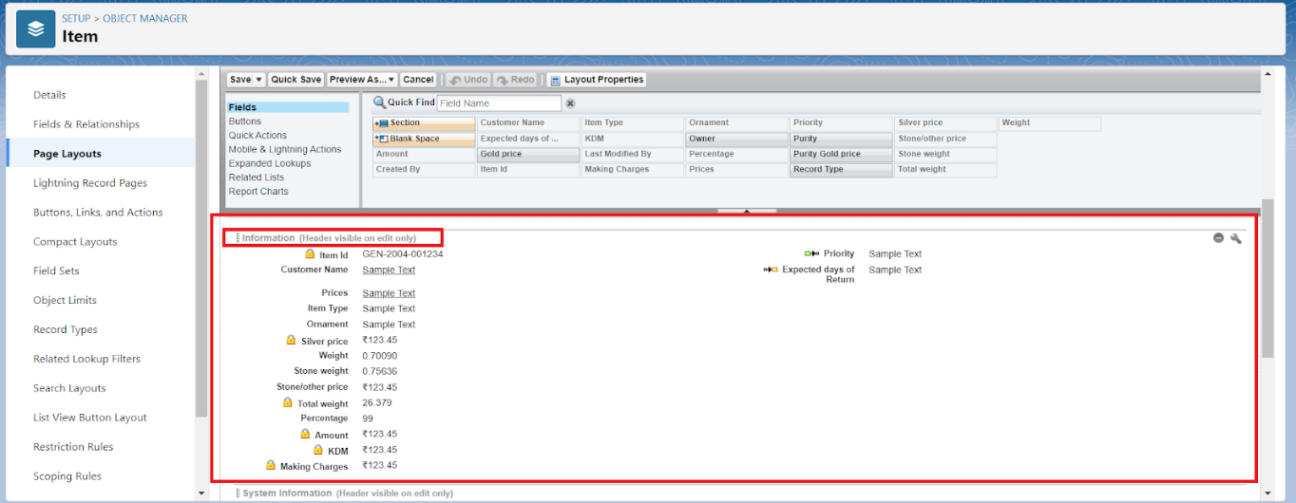

### **Record Types**

Record Types are a way of grouping many records of one type for that object. These can be applied to any standard or custom object, and allow you to have a different page layout, fields, required fields, and picklist values. Record types allow administrators to create a different page layout with custom picklist fields and values for the same business process and various business processes.

**To create a Record Type**

* Go to setup >> click on Object Manager >> type object name (Item) in quick find bar? click on the object.
* Click on the Record Types >> click New.
* Select Existing Record as “Master”, Record type Label as “Gold”, Description as “Gold items information”.
* Uncheck for “Make Available”.
* Scroll down and check for the Gold Smith, Worker JW & System Administrator profile and click on Next
* Select “Apply a different layout for each profile”, and change page layout to “Page Layout for Gold for Gold Smith, Worker and System Administrator? save & new.

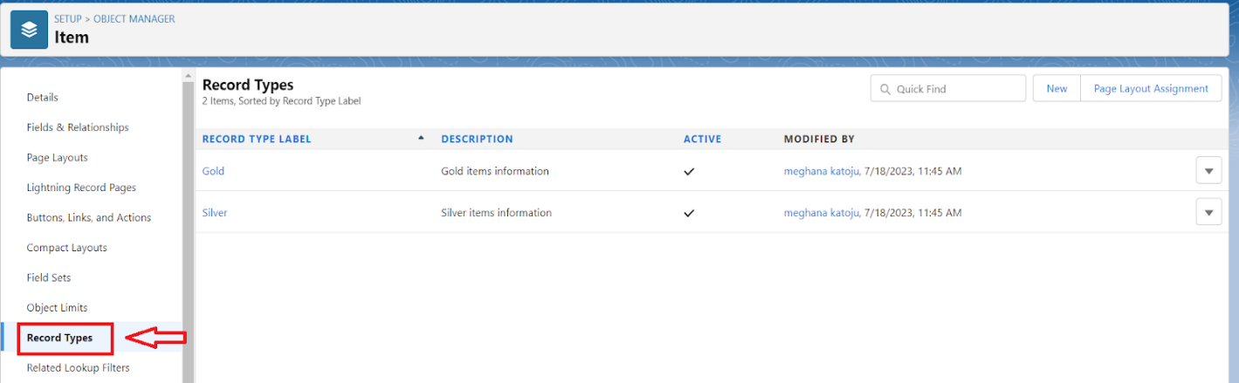

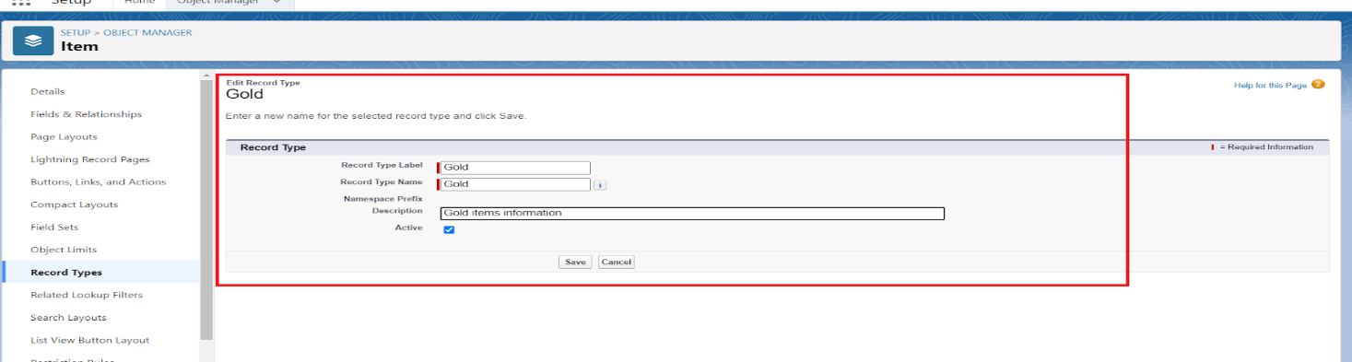

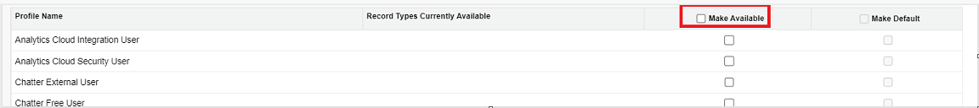

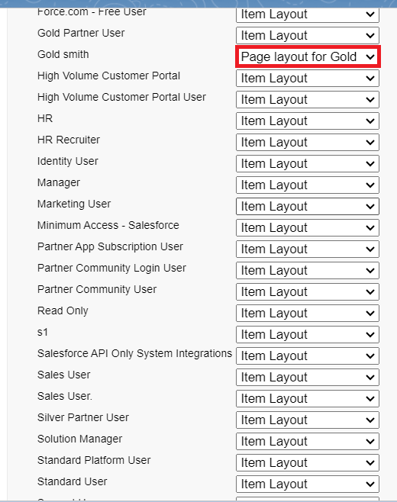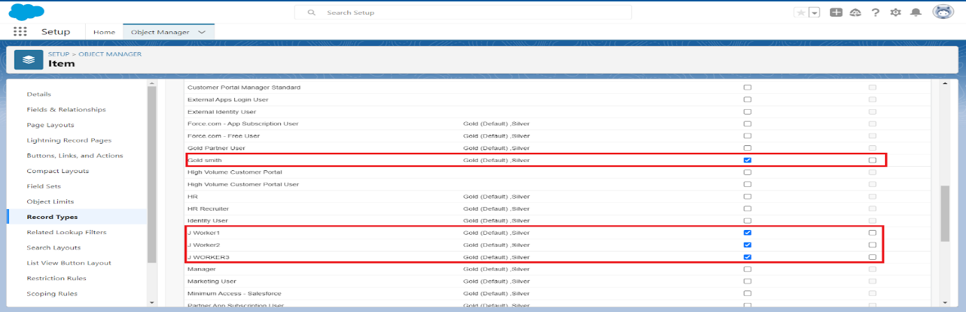

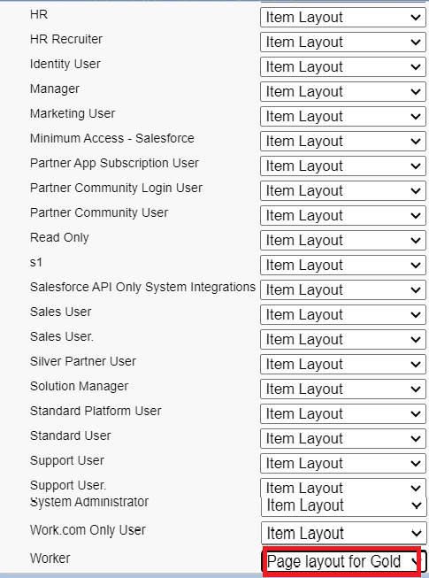

## Activity 2: Create another Record Type with name “Silver” following the steps from Activity1.

Note: Use page layout for Silver.

### **Permission sets**

A standard permission set consists of a group of common permissions for a particular feature associated with a permission set licence. Using a standard permission set saves you time and facilitates administration because you don't need to create the custom permission set.

**Creating permission set**

A permission set is a collection of settings and permissions that give users access to various tools and functions. Permission sets extend users' functional access without changing their profiles. Users can have only one profile but, depending on the Salesforce edition, they can have multiple permission sets.

* Go to setup >> type “permission sets” in quick search >> select permission sets >> New.
* Enter the label name as “Per to Worker”, API will be auto populated? save.
* Under Apps Select object settings.
* Click on Items object? click on Edit? under Item: Record Type Assignments, enable Gold, Silver? Object permission check for read, edit and create.
* Click on Save.
* After saving the permission click on the Manage assignment
* Now click on the Add Assignment.
* Now select the users which you have created in user milestone, using Worker profile and click on Next? Assign? Done.

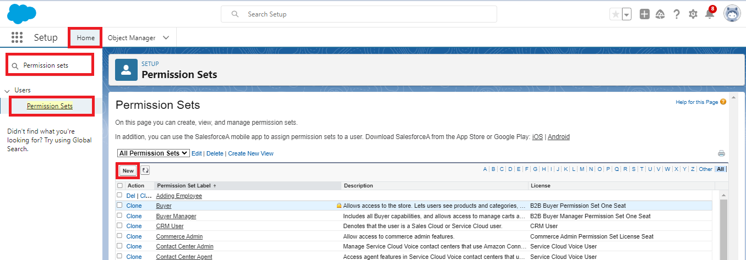 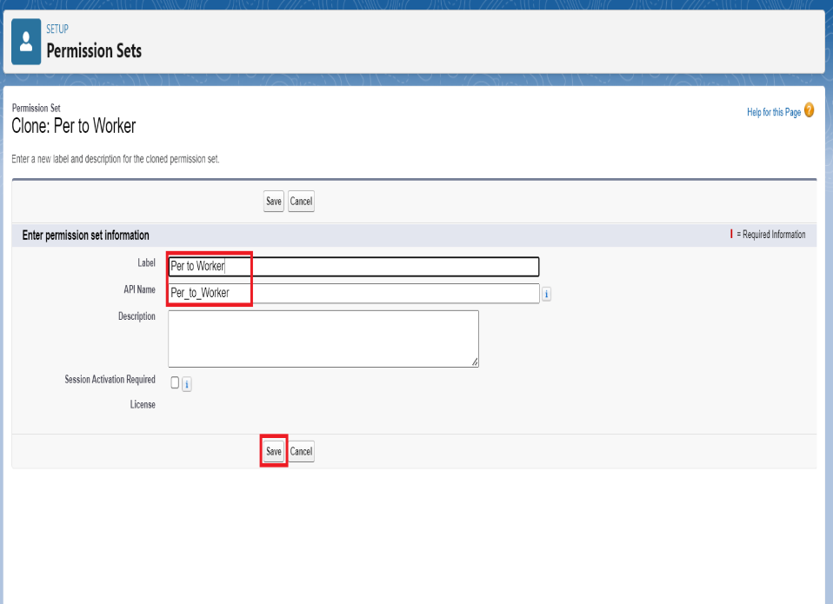

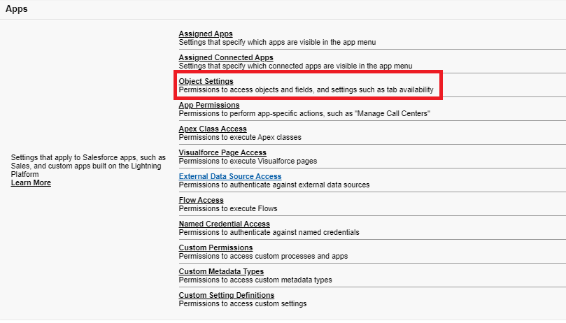 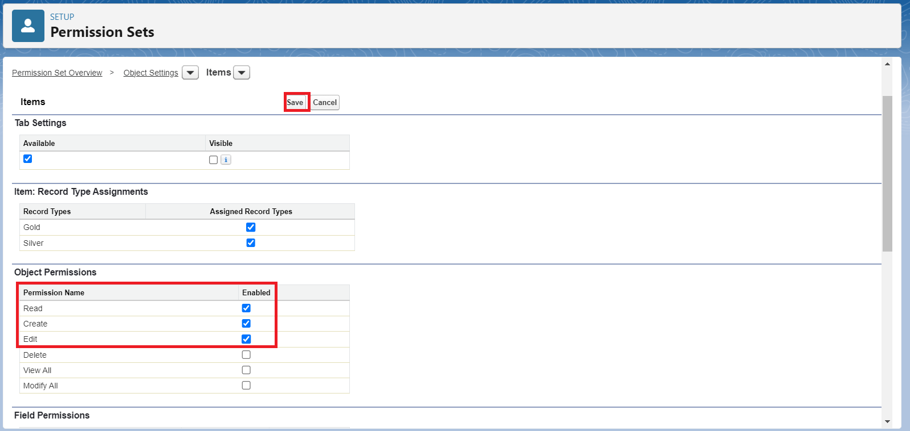

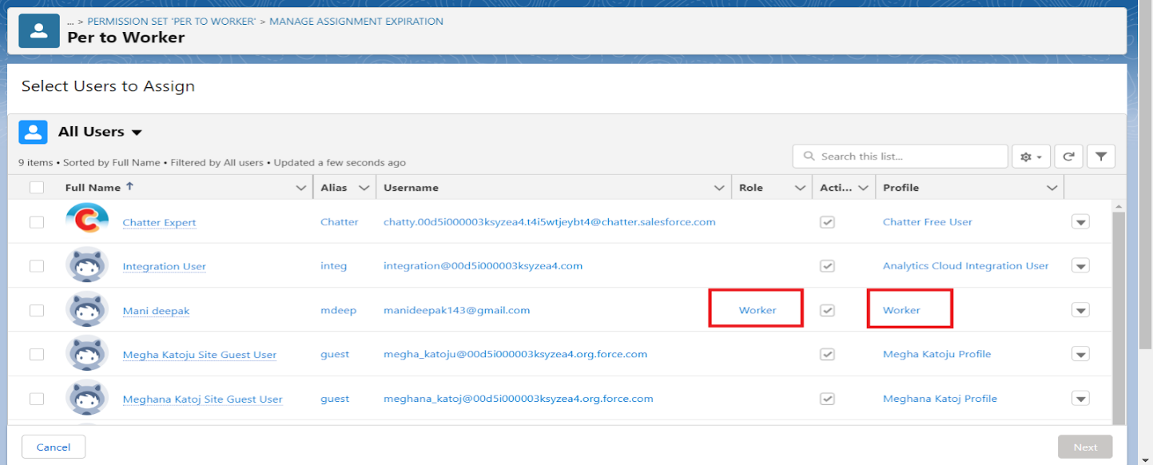

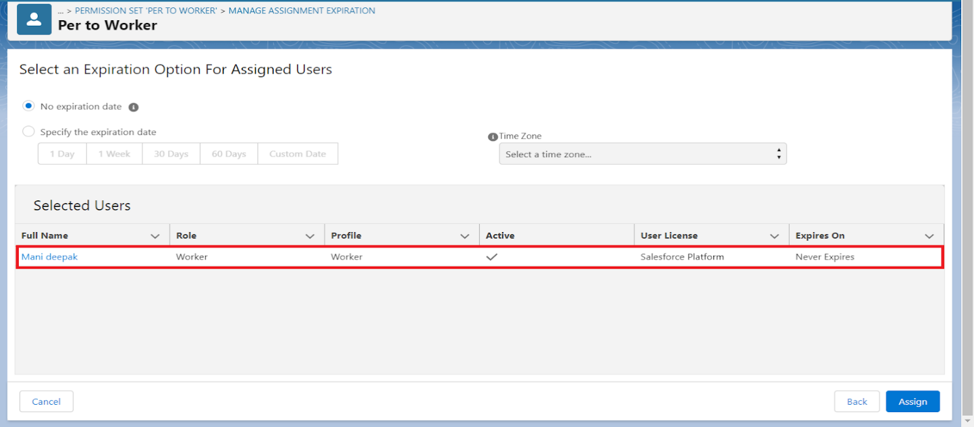

**Trigger**

A trigger is a piece of Apex code that automatically runs before or after specific events, like record insertion, update, or deletion. Triggers are used to customise and automate actions in response to these events.

### **Create a Trigger Handler class**

**Trigger handler:**

A trigger handler is a design pattern that organises trigger logic into separate classes. This helps in keeping code organised, reusable, and easier to maintain. The trigger handler class contains methods that handle the specific logic for different trigger events, improving code structure and readability. This approach is particularly useful for complex triggers or projects with multiple triggers, as it promotes modular coding practices and reduces the chances of code duplication.

**CODE**

public class UpdatePaidAmountTriggerHandler {

    public static void handleBeforeInsert(List<Billing__c> newBillings) {

        for (Billing__c billing : newBillings) {

            billing.Paid_Amount__c = billing.Paying_Amount__c;

        }

    }

public static void handleBeforeUpdate(Map<Id, Billing__c> oldBillingsMap, List<Billing__c> updatedBillings) {

        for (Billing__c billing : updatedBillings) {

            Billing__c oldBilling = oldBillingsMap.get(billing.Id);

            Decimal oldPaidAmount = oldBilling.Paid_Amount__c;

            billing.Paid_Amount__c = oldPaidAmount + billing.Paying_Amount__c;

        }

    }

}

### **Create the trigger**

**CODE**

trigger UpdatePaidAmountTrigger on Billing__c (before insert, before update) {

    if (Trigger.isInsert) {

        UpdatePaidAmountTriggerHandler.handleBeforeInsert(Trigger.new);

    } else if (Trigger.isUpdate) {

        UpdatePaidAmountTriggerHandler.handleBeforeUpdate(Trigger.oldMap, Trigger.new);

    }

}

### **User Adoption**

### **Create a Record (Jewel Customer)**

1. Click on App Launcher on the left side of the screen.
2. Search Jewelry Inventory System & click on it.
3. Click on Drop Down and Click on the Jewel Customer tab.
4. Click New.
5. Fill the Details and click on Save.

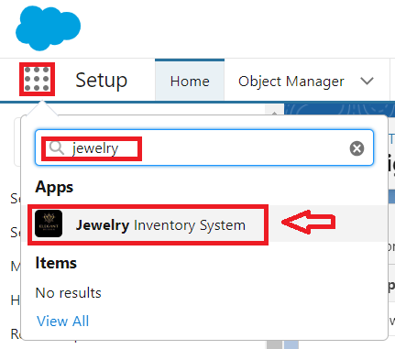 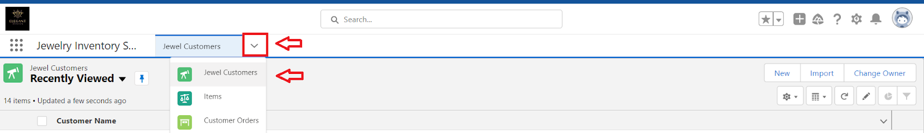

### **View a Record (Jewel Customer)**

1. Click on App Launcher on the left side of the screen.
2. Search Jewelry Inventory System & click on it.
3. Click on the Jewel Customer Tab.
4. Click on any record name. you can see the details of the Jewel Customer.

**Delete a Record (Jewel Customer)**

1. Click on App Launcher on the left side of the screen.
2. Search Jewelry Inventory System & click on it.
3. Click on the Jewel Customer Tab.
4. Click on Arrow at right hand side on that Particular record.
5. Click delete.

**Note: Create at least 10 records for each of the objects: Jewel Customer, Price, Item, Customer Order and Billing.**

**Reports**

Reports give you access to your Salesforce data. You can examine your Salesforce data in almost infinite combinations, display it in easy-to-understand formats, and share the resulting insights with others. Before building, reading, and sharing reports, review these reporting basics.

**Types of Reports in Salesforce**

1. Tabular
2. Summary
3. Matrix
4. Joined Reports

**Create Report**

1. Go to the app >> click on the reports tab
2. Click New Report.
3. Select report type from category or from report type panel or from search panel? click on start report.
4. Customise your report and save or run it.

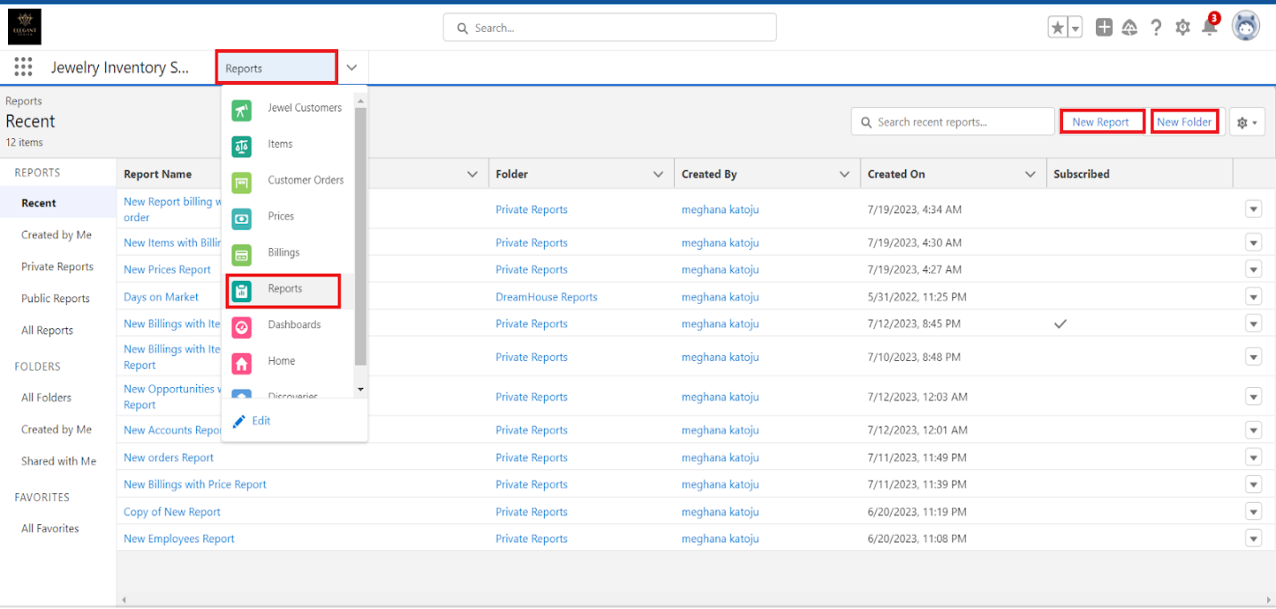

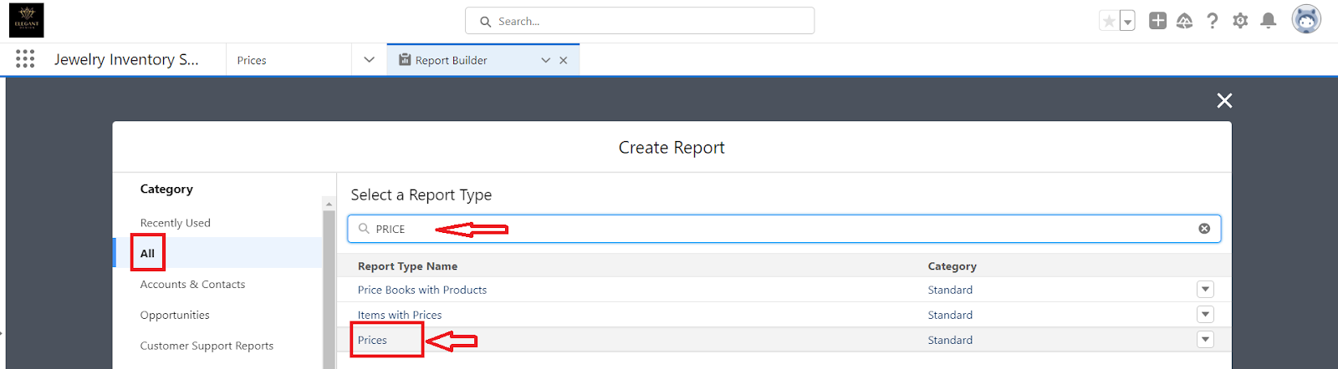

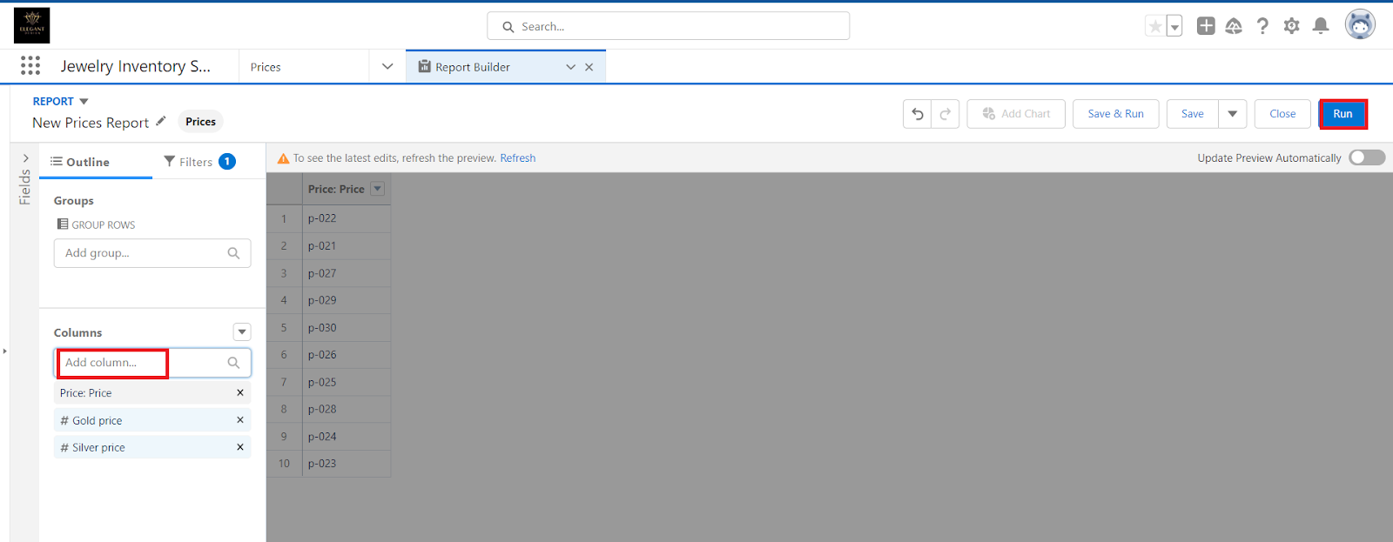

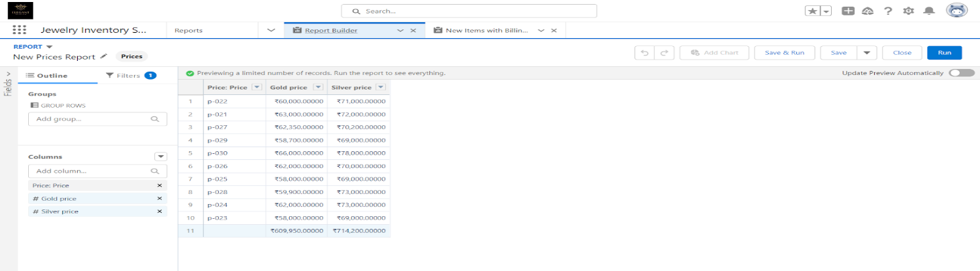

### **Reports**

1. Create a report with report type: “Item with Billings”.
2. Create a report with report type: “Billings with item and Customer order”.

**Dashboards**

Dashboards help you visually understand changing business conditions so you can make decisions based on the real-time data you’ve gathered with reports. Use dashboards to help users identify trends, sort out quantities, and measure the impact of their activities. Before building, reading, and sharing dashboards, review these dashboard basics.

**Create Dashboard**

1. Go to the app >> click on the Dashboards tabs.
2. Give a Name and click on Create.
3. Select add component.
4. Select a Report and click on select.
5. Click Add then click on Save and then click on Done.

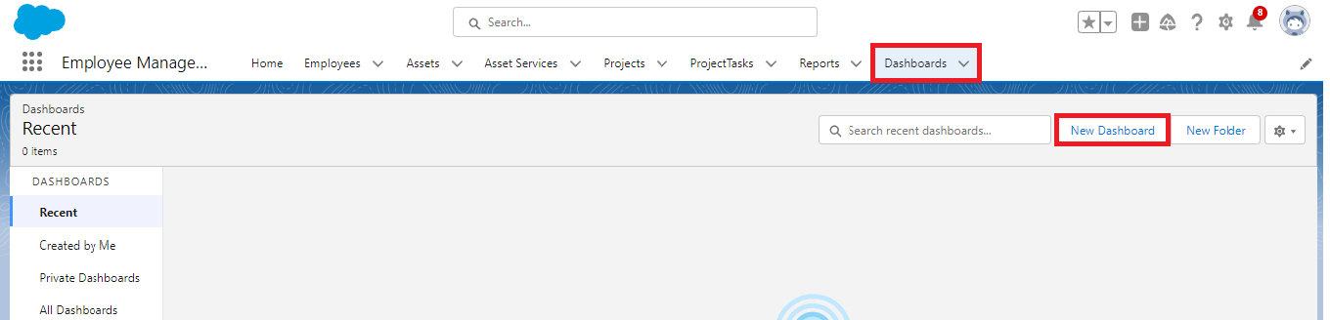

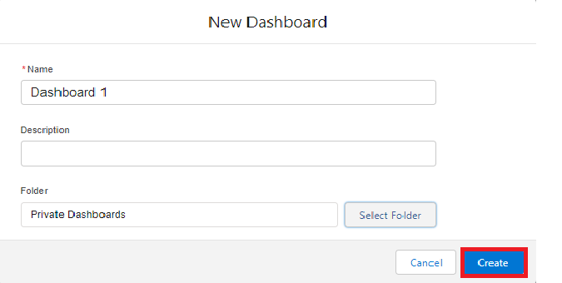



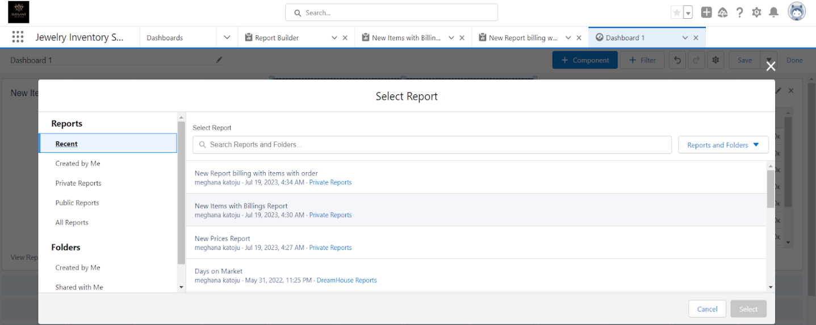

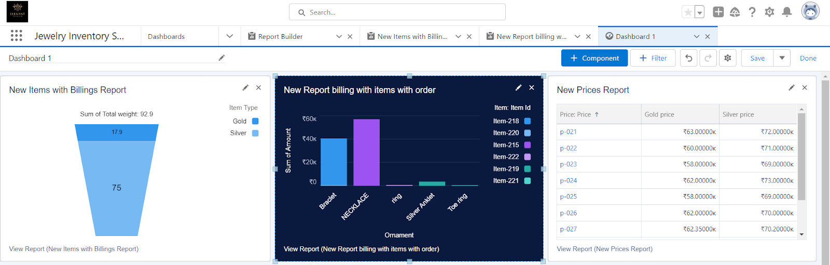

## Note: Activity 2 Create another Dashboard as we discussed in activity 1

### **Flows**

In Salesforce, a flow is a powerful tool that allows you to automate business processes, collect and update data, and guide users through a series of screens or steps. Flows are built using a visual interface and can be created without any coding knowledge.

**Create a Flow**

1. Go to setup >> type Flow in quick find box >> Click on the Flow and Select the New Flow.
2. Select the Record-triggered flow and Click on Create.
3. Select the Object as a “Billing” in the Dropdown list.
4. Select the Trigger Flow when: “A record is Created or Updated”.
5. Select the Optimise the flow for: “Actions and Related Records” and Click on Done.
6. Now change the mode form Auto-layout to free-form.
7. Now select the manger option in the toolbox, click New resource.
8. Select the resource type as text template.
9. Enter the API name as “Email body”.
10. Change the view as Rich Text? View to Plain Text.
11. In the body field paste the syntax that is given below.
12. Click done.
13. Now click on elements, and drag the action element into the preview pane.
14. Their action bar will be opened in that search for “send email” and click on it.
15. Give the label name as “notice”
16. API name will be auto populated.
17. Enable the body in set input values for the selected action.
18. Select the text template that was created.
19. Include Recipient Address list, select the email form the record.
20. Include the subject as “Welcome to Jewelry Inventory System”.
21. Click done.
22. Now drag the path from the start to the action element.
23. Click on save. Given the Flow label, Flow API name will be auto populated.
24. And click save, and click on activate.

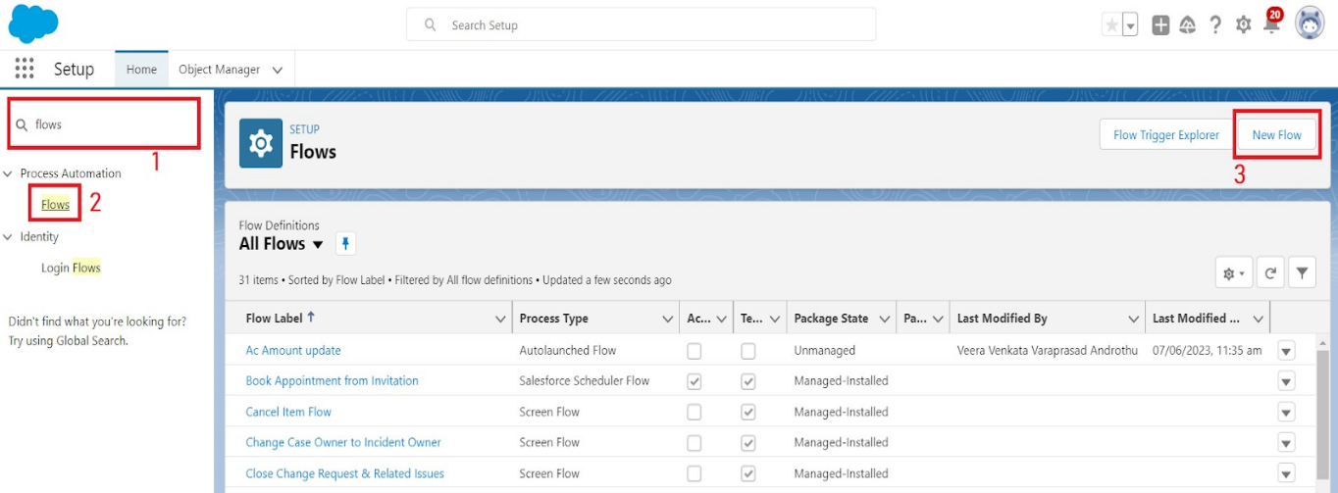

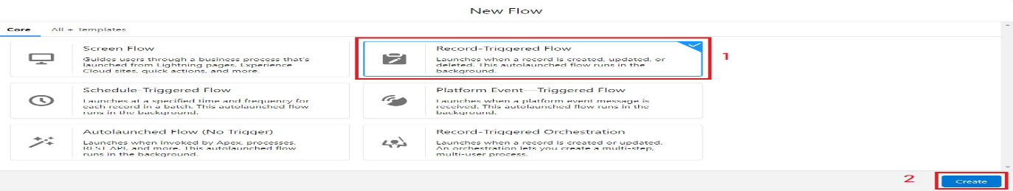

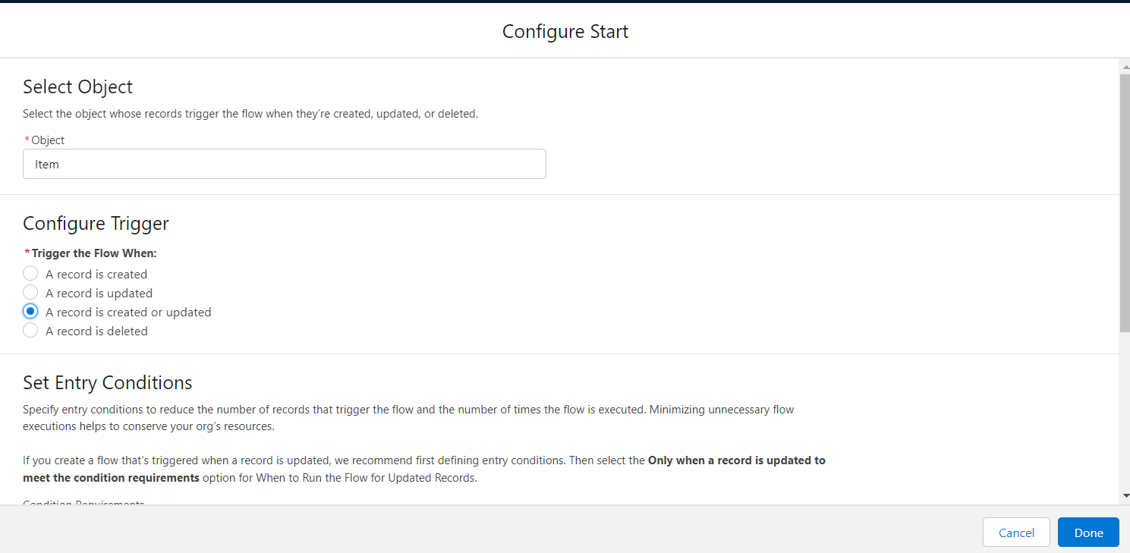

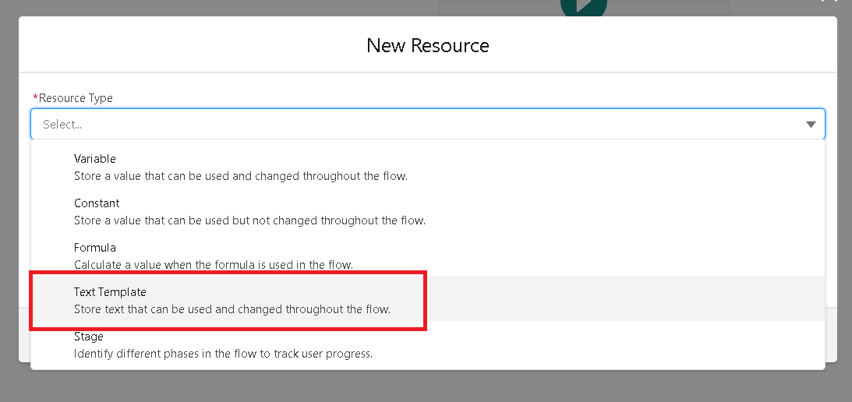

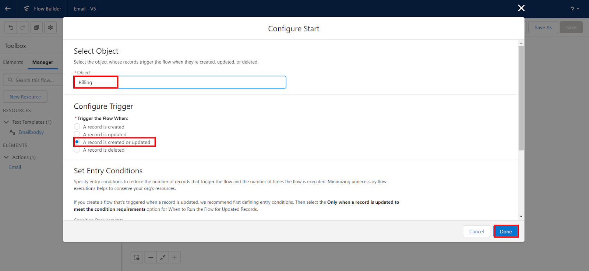 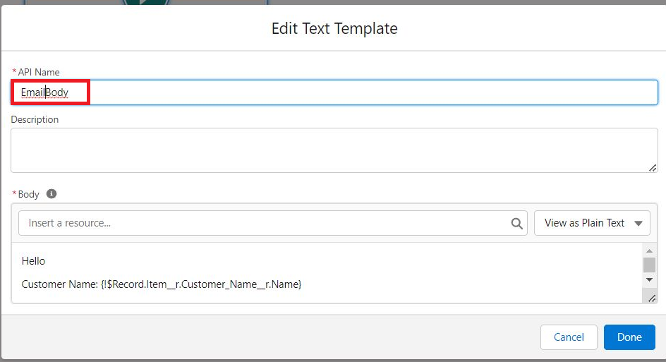

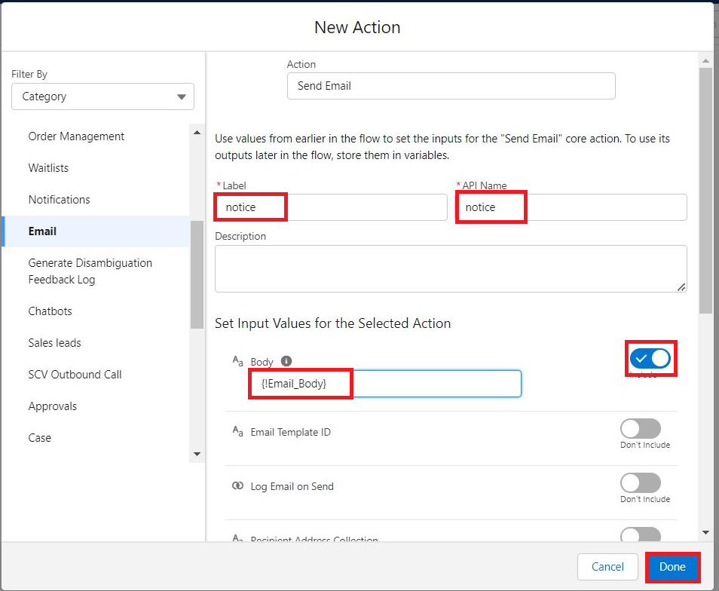

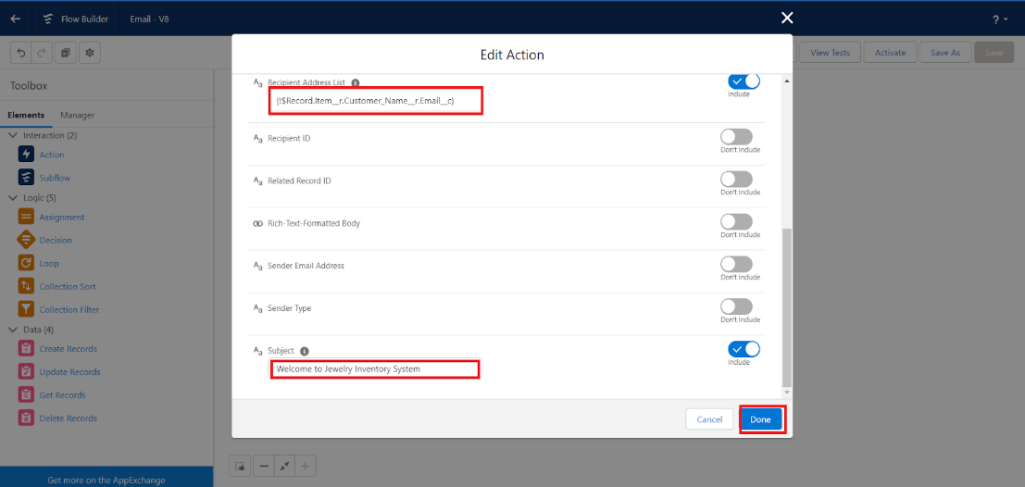 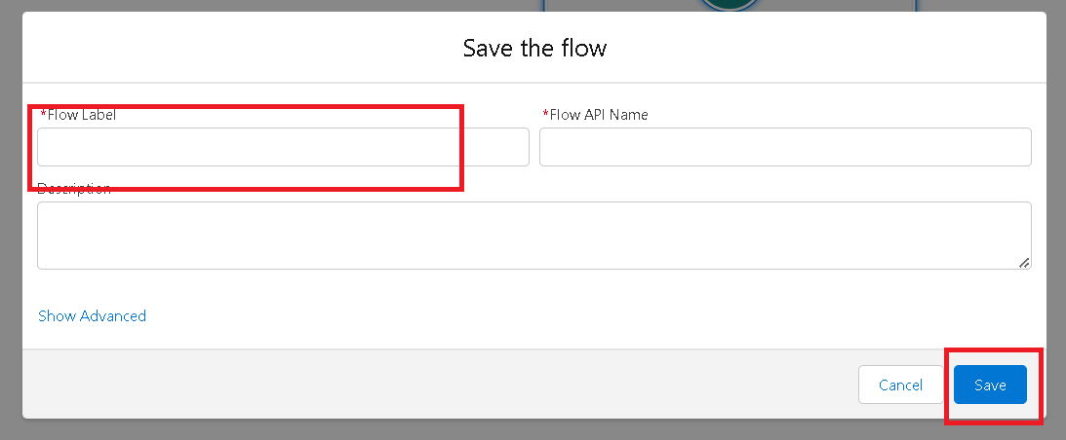

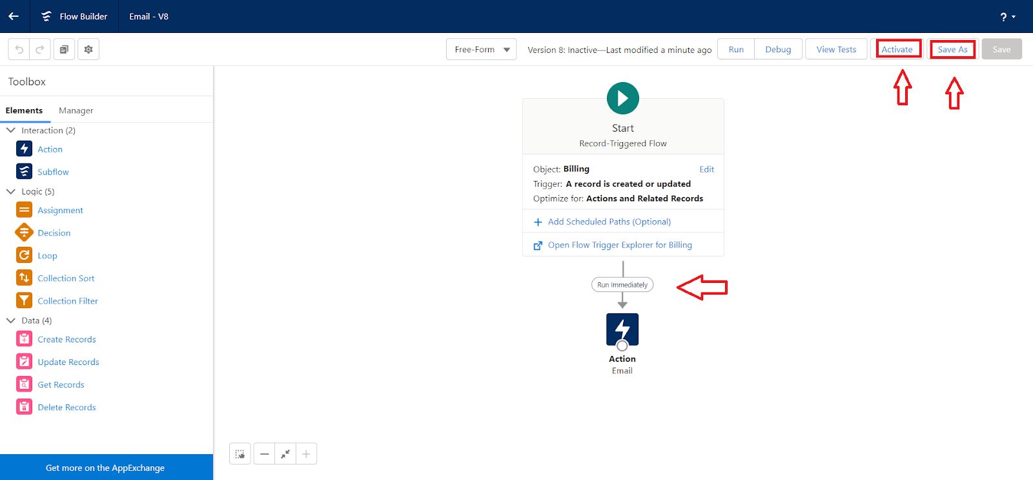

**PERFORMANCE TESTING**

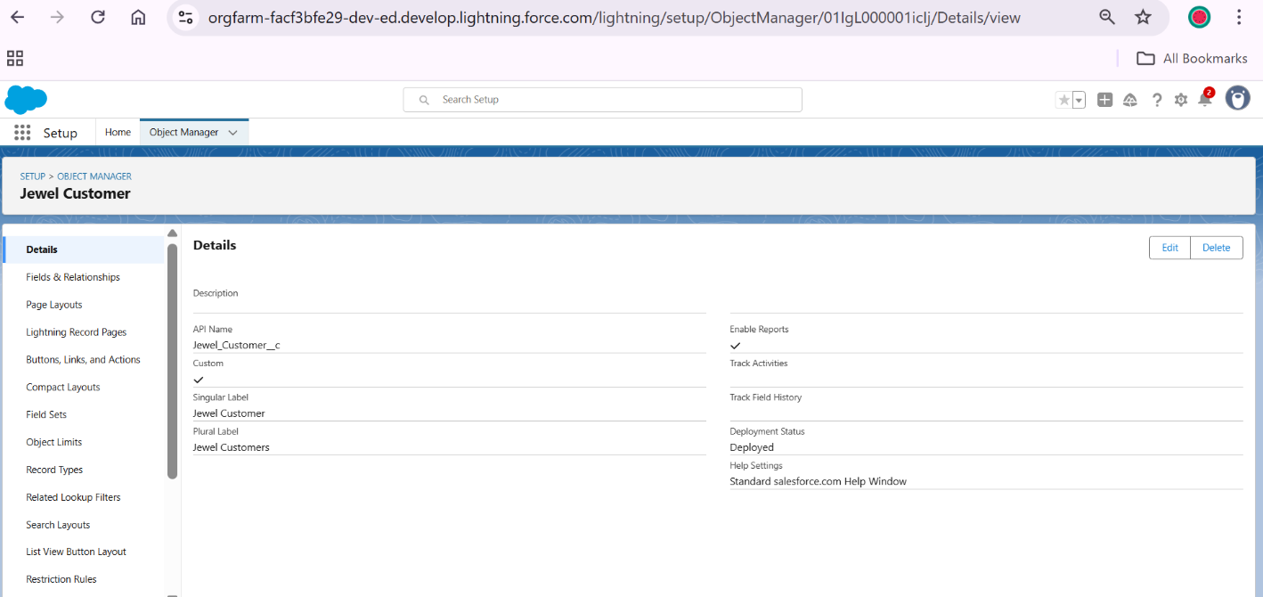

**Jewel Customer Creation Page**

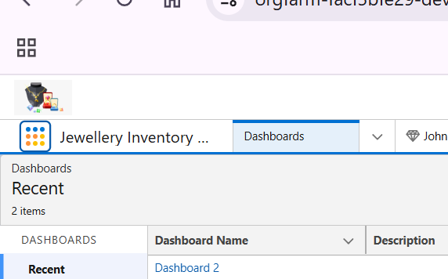

**Jewellery Inventory App**

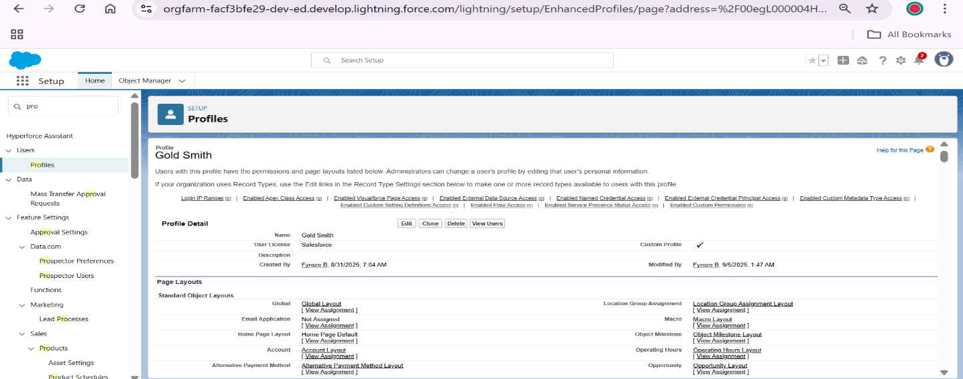

**Gold Smith Profile Creation**

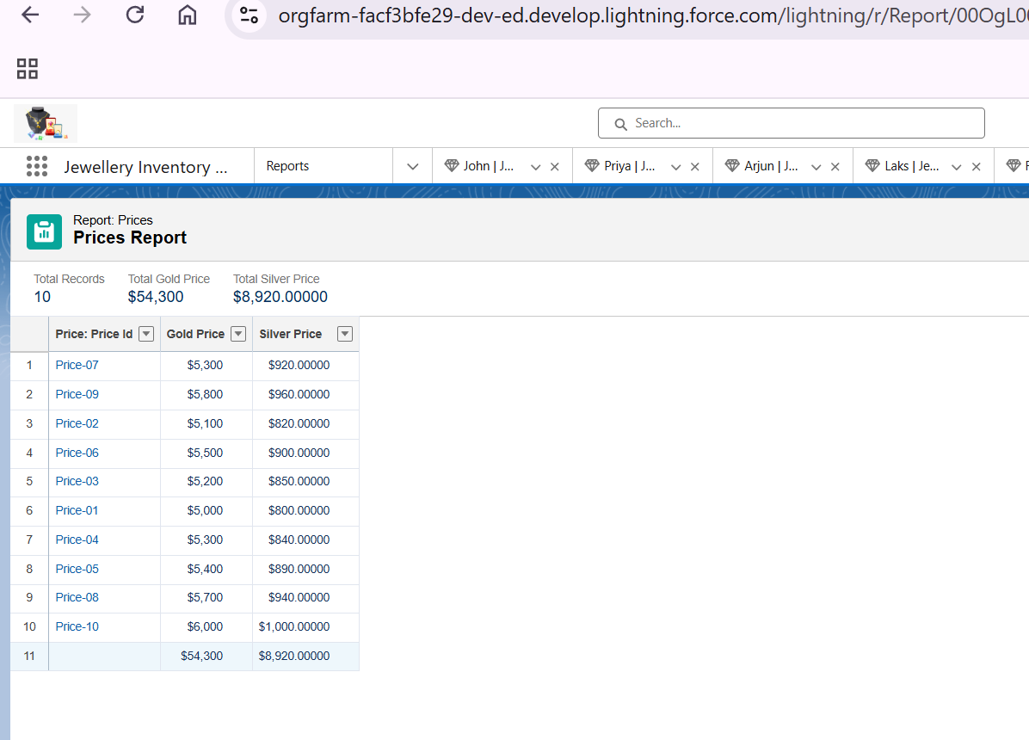

**Reports Creation**

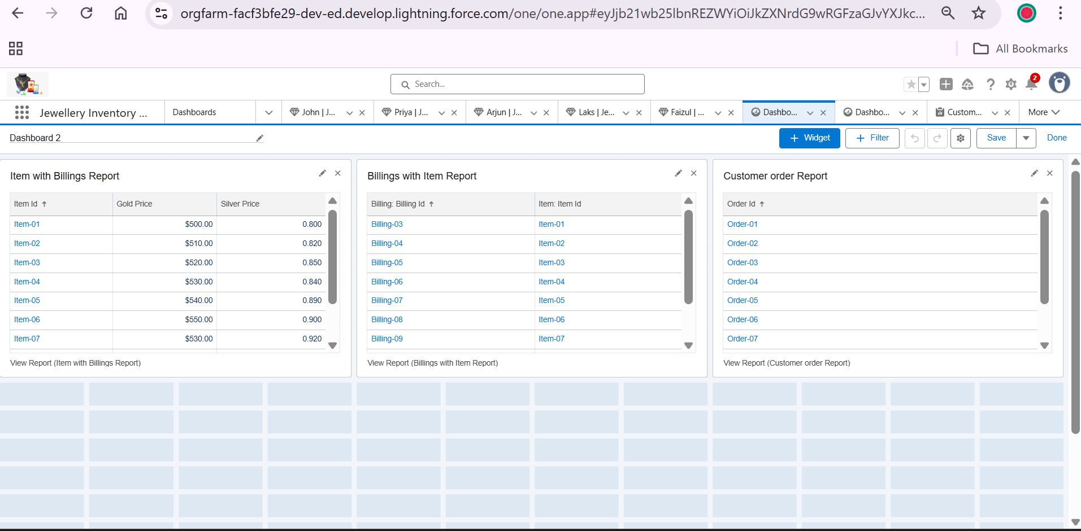

**Dashboard Creation**

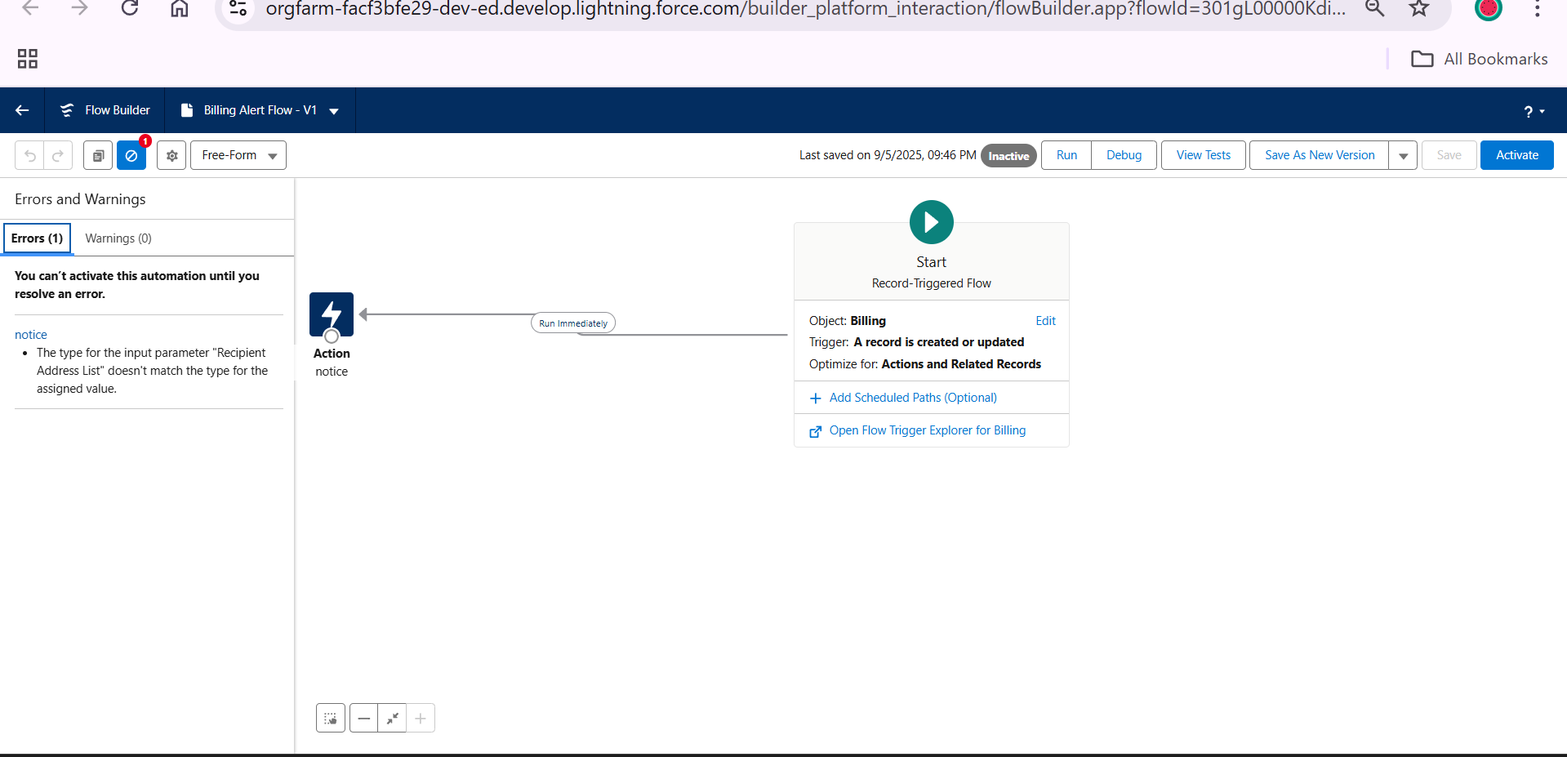

**Flows Creation**

**CONCLUSION**

The CRM Application for Jewel Management effectively streamlines the inventory and sales operations of a jewellery business by leveraging the capabilities of the Salesforce platform. This project focuses on building a user-friendly and reliable system that simplifies tracking of jewellery items, manages customer data, and facilitates smooth sales transactions. Through key Salesforce features like data modelling, custom objects, validation rules, flows, reports, and dashboards, the application ensures improved data accuracy, operational efficiency, and better decision-making.

By implementing UI customization, record types, conditional formatting, and email automation, the system enhances the overall user experience and reduces manual errors. The project not only demonstrates a strong understanding of core Salesforce concepts but also provides a practical solution tailored for real-world business needs in the jewellery domain. This foundation opens up opportunities for future scalability, such as integrating with e-commerce platforms or adding AI-based customer insights, making it a valuable asset for modern jewellery businesses.

lities f